SEM for Purchase Intention of Home Video Game Consoles

John Sum, Mario Wei-Ting Liao,
Department of Electronic Commerce National Chung Hsing University, Taiwan
(pfsum@nchu.edu.tw, mitkeyness@yahoo.com.hk)

ABSTRACT
This paper presents a conceptual model to analyze the casual relations of product characteristics, product compatibility, brand image, price and word-of-mouth (WoM) to the purchase intention of home video game consoles. Samples are collected from students in different universities. It is found that (1) word-of-mouth communication has a positive direct impact on purchase intention; (2) brand image has positive but not strong impact on purchase intention; (3) product characteristics and compatibility have direct positive impact to WoM and brand image; (4) compatibility has direct negative impact to purchase intention; (5) price has little positive impact to purchase intention. Finally, the same dataset is plugged in three other competing models with different casual relations amongst those factors for validation. It is found that the conceptual model is still the best in fitting and explanatory power in comparison with other three competing models.

Keywords: Home Video Game Consoles, Purchase Intention, Brand, Word-of-Mouth Communication, SEM, Validation

1. INTRODUCTION

Market development of home video game console has been an increasing concern since the first home video game console “Magnavox Odyssey” launched in 1972. Nowadays, the sale volume of home video game consoles has grown to $88 hundred million (iSuppli’s Report, 2008). In accordance with VGCHART.com, Nintendo Wii records 39 million sales in 2008. Microsoft XBOX360 records around 24 million and Sony PS3 records around 18 million. Large sale volume of Wii reveals a new market segment that has not been aware by Microsoft and Sony. Those who love to play with simple but interactive control. Thus, how to evoke purchase intention for home video game console and identify variables of concern to consumers owing to understand the current market environment will be inevitable.

The purchase intention could be affected by the confidence behind a consumer’s mind (Howard and Sheth 1969) (Bennett and Harrell 1975) (Howard 1989) (Urbany, Dickson et al. 1989), which is related to the consumer’s knowledge on a product. While a holistic view on the confidence behind a consumer’s mind in home video game console has not reported, it is possible to hypothesize in accordance with previous studies on the same issue and interview with game console players that price (Gray M. Erickson and Johansson 1985), product characteristics (Lyman E. Ostlund 1974; Susan L. Holak 1988; Rosemary R. Seva, Henry Been-Lirn Duh et al. 2007), compatibility (Peter C.R. 1979; Susan L. Holak and Lehmann 1990; Dhebar 1995), brand (Chernatony and McWilliam 1989), word-of-mouth communication (Patricia A. Goering 1985) are the key factors governing the purchase intention. Furthermore, word-of-mouth positively affects choice of brand in decision making.

The objectives of this study four folds: (1) develop the general model, which investigates how to stimulate the consumers’ purchase intention from different viewpoints, (2) identify underlying variables, (3) validate a causal relationships, and (4) combine the individual factor and social network in decision making. We are not to refute the traditional theoretical framework but to provide clarity and enable marketing manager to align strategies under market condition.

2. METHODOLOGY

Six steps are carried out to examine the causal relationship in this study. In Step 1, the factors which affect the purchase intention are recognized by interviewing professional players who have sufficient experience in purchasing a game console. In Step 2, together with background survey, we conceptualize the theoretical model and design the questionnaire. In Step 3, 100 samples are collected from students at university level. Preliminary analysis is conducted. In Step 4, items with added, deleted, modified is conducted to establish reliability and validity. The final 18 items are retained and are tapped into 6 underlying variable. This study follows the structural equation modeling (SEM) approach (detail see 3.2) and estimates maximum likelihood (ML) estimation and generalized least-squared (GLS) estimation respectively. The reason are1) ML is assumed samples are followed Gaussian distribution and 2) in contrast, GLS is assumed samples are followed non-Gaussian distribution (O'Guinn and Shrum 1997; Augusto de Matos, Ituassu et al. 2007; Margherita 2007; Pagani; 2007). Then, we identify four possible estimated models (include conceptual model) to validate the plausible model in Step 5. The plausible is validate based on model fit indices, significant determinant, and squared multiple correlations (SMC). In Step 6, we investigate on the interpretation of the plausible model and give conclusion.

After the questionnaire has been redesigned, we have collected in total 320, and only 250 are useful. Their demographic characteristics are depicted in Table 2-1.

Table 2-1 Demographic characteristics of the respondents
Characteristics |  | N=250 | Percentage %
Gender
Male |  | 162 | 64.8
Female |  | 88 | 35.2
Age
Under 20 |  | 25 | 10
21-30 |  | 190 | 76
31-40 |  | 35 | 14
Years of experience on HVGC
Under 1 |  | 34 | 13.6
2-5 |  | 46 | 18.4
6-10 |  | 115 | 46
Above 11 |  | 55 | 22
Occupation
Student |  | 172 | 68.8
An employee in private enterprise |  | 26 | 10.4
An employee in government |  | 10 | 4
Freelance |  | 36 | 14.4
Experts in HVCG |  | 6 | 2.4
Range of reasonable price on HVGC
Under 5,000 |  | 48 | 19.2
5,000~10,000 |  | 178 | 71.2
11,000~15,000 |  | 10 | 4
16,000 or above |  | 6 | 2.5
The HVGC that you have played ever
Nintendo Super Family Computer |  | 217 | 86.8
Nintendo Super Famicom |  | 174 | 69.9
Nintendo 64 (N64) |  | 135 | 54
Nintendo Wii |  | 178 | 71.2
Sega Dreamcast |  | 45 | 18
Sega MegaDrive |  | 101 | 40.4
SONY Playstation 1 |  | 219 | 87.6
SONY Playstation 2 |  | 92 | 36.8
SONY Playstation 3 |  | 47 | 18.8
Microsoft XBOX |  | 149 | 59.6
Microsoft XBOX 360 | 132 |  |  | 52.8

3. CONCEPTUAL MODEL

This section presents hypotheses in the conceptual model of interest and brief introduction on hypothesizing test. Both null (H₀) and alternative (H_{a}) hypotheses are required in this study. In the conceptual model, it combines three exogenous latent variables and three endogenous latent variables. Those hypotheses are based on background survey and suggestions. Due to the page limit, we omit the detail explanation why we come up with those hypotheses. Interested reader can refer to Mario Liao’s Master Thesis for detail.

H1a: The brand has a positive significant impact on purchase intention of home video game console.
H2a: The compatibility has a positive significant impact on purchase intention of home video game console.
H3a: The compatibility has a positive significant impact on WOM communication.
H4a: The price has a positive significant impact on purchase intention of home video game console.
H5a: The product characteristic has a positive significant impact on the brand
H6a: The product characteristic has a positive significant impact on word-of-mouth (WOM) communication.
H7a: The product characteristic has a positive significant impact on brand.
H8a: The WOM communication has a positive significant impact on purchase intention.
H9a: The WOM communication has a positive significant impact on the brand.

4. PRELIMINARY TEST

4.1 Scale Reliability & Validity

Measuring the reliability and validity is an essential when we use structural equation modeling (SEM) approach. The standardized factor loading and accompanying significant determinants must be estimated. All items are in accordance with the rule which factor loading must be reached 0.5 or above (J.C.; and D.W.; 1988). In contract, items of factor loading less 0.5 shall delete before following test, so as to ensure that construct validity and composite reliability are satisfactory value.

In processes of refining the scale, problems occur that a part items is less than psychometric properties; i.e., their contribution of item are influenced by dimensions of construct. Simultaneously, we decide to narrow the domain of coverage of price, brand, and word-of-mouth communication of construct to refine appropriate scale. For example, the original items toward price attempts to capture all cues related to brand name, as well as other items that might contribute to overall price of construct (e.g., the range of product’s price or pre-use the “cheaper” than other video game console). But factor analysis indicates only three items with high factor loadings enable be represents as price of construct. Items 1, 3, and 6 shall be deleted.

For instance, the initial items related to brand attempt to capture information concerning whether the brand is represented as symbolic brand image and risk when consumers use the product, as well as other items that may contribute to brand (e.g., high market-share of brand, or the brand of product that has been used). The result reflects only item 1, 2, and 3 are acceptable in terms of loading above 0.5.

It is worth mentioning that items which less than 0.6 are still retained because those items are extremely important to measure its variables. The item “C3”, for instance, refers to whether the controller to be compatible with game console.” C3 still retains due to operational method of the controller since Nintendo Will had been released the novel controller with sensor in 2007”, said all professional players. It shifts consumers’ attention distract from main devices to the controller function. The consumers seem to judge whether to get enjoy from controller. With reference to Dhebar (1995), he supported that the compatibility is measured by switching cost, learning cost, and complementary product. Higher price of game console may not affect the purchase intention in game console industry, said one of them.

Moreover, the items pertaining to this study measures a total of 18 items after factor loading test: three items referred to price, three items related to product characteristics, three items referred to compatibility, three items related to brand, three items referred to word-of-mouth communication, and three items related to purchase intention. Total of 14 items are deleted due to factor loading on each variable. Responses are required to fill in panes using five-point Likert-scale, where 1 serves as “strongly disagree” and 5 serves as “strongly agree”.

After all, the standardized factor loading, internal composite reliability and average variance extracted of the scale are analyzed. The figures are depicted in Table 4-1.

4.2 Model Fit

The structural equation modeling (SEM) applied SAS 8.0 estimated parameters among variables. The path coefficient among variables would be marked and shown the significant determinants. In conceptual model of interest, latent exogenous variables are composed of price (ξ₁), product characteristics (ξ₂), and compatibility (ξ₃). Latent endogenous variables are composed of brand (η₁), word-of-mouth communication (η₂), and purchase intention (η₃). Each variable is measured by three items directly.

In the preliminary results, the performance is shown with GFI, AGFI, RMR, RMSEA, CFI, and NFI values of 0.82, .079, 0.11, 0.07, 0.80, and 0.75. Two paths which indicate between price and brand and between price and purchase intention isn’t found the significant determinants. The price is eliminated temporarily after discussing with professional players. We validate the estimated model concluded price and non-price; respectively, estimate by maximum likelihood (ML) and generalized least-squared (GLS). Last, the plausible model will be validation.

Table 4-1 Standardized factor loading, internal composite reliability and average variance extracted of the scale

Variables and items | Construct reliability and validity
Variables and items | Standardized Factor Loading | Comp.  Rel. | Avg. Variance
Price
P1 | 0.53 | 0.83 | 0.77
P2 | 0.75 | 0.83 | 0.77
P2 | 0.69 | 0.83 | 0.77
Product Characteristics
PC1 | 0.85 | 0.96 | 0.90
PC2 | 0.82 | 0.96 | 0.90
PC3 | 0.59 | 0.96 | 0.90
Compatibility
C1 | 0.76 | 0.95 | 0.86
C2 | 0.70 | 0.95 | 0.86
C3 | 0.56 | 0.95 | 0.86
Brand
B1 | 0.80 | 0.90 | 0.75
B2 | 0.87 | 0.90 | 0.75
B3 | 0.74 | 0.90 | 0.75
Word-of-mouth Communication
WOM1 | 0.76 | 0.90 | 0.74
WOM2 | 0.76 | 0.90 | 0.74
WOM3 | 0.81 | 0.90 | 0.74
Purchase Intention
PI1 | 0.73 | 0.92 | 0.79
PI2 | 0.80 | 0.92 | 0.79
PI3 | 0.84 | 0.92 | 0.79

5. STATISTICAL ANALYSIS

As a results, four different models are, as shown in Table 5-1, are examined. It should be noted that Model 1 is our original conceptual model. Model 2 to Model 4 are for competitive analysis. To avoid our conclusions not being bias to one particular estimation method, maximum likelihood (ML) and generalized least-squared (GLS) are applied to identify the models. For presentation purpose, we use the following notation to represent a model: Model 1_{ML}, Model 1_{GLS} correspond to the model with structure the same as Model 1 and the parameters are estimated by maximum likelihood.

For each model, the following indices are recorded for comparison: Goodness of fit index (GFI), adjusted goodness of fit index (AGFI), parsimonious goodness-of-fit index (PGFI), root mean residual (RMR), root mean squares error of approximation (RMSEA), comparative fix index (CFI) and normed fit index (NFI).

Table 5-1 Model identification
Model 1 | Model 2
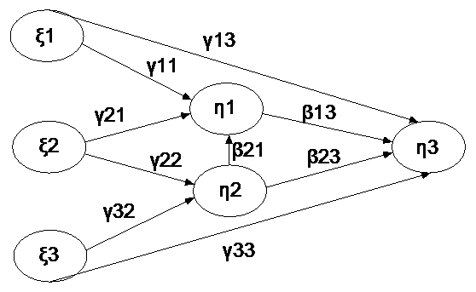 | 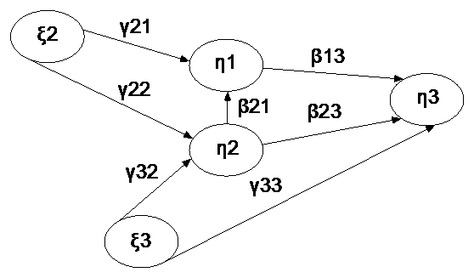
Model 3 | Model 4
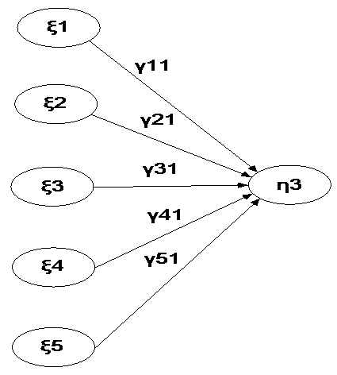 | 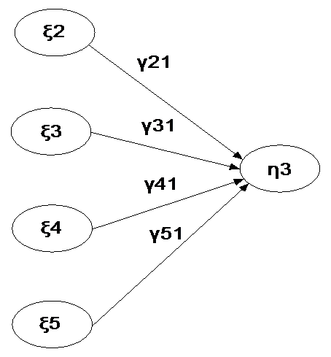

5.1 Model 1_{ML}

The model 1 is estimated by ML and GLS respectively as same as model 2, 3 and 4. Model 1_{ML} provides acceptable values, with goodness of fit index (GFI), adjusted goodness of fit index (AGFI), parsimonious goodness-of-fit index (PGFI), root mean residual (RMR), root mean squares error of approximation (RMSEA), comparative fix index (CFI) and normed fit index (NFI) values of 0.89, 0.84, 0.70, 0.10, 0.07, 0.86, and 0.79.

Results indicates the price (γ13=0.26, p<0.01) has significance determinant on purchase intention and (γ11=0.22, p<0.01) has significant determinant on bran. The product characteristics (γ21=0.25, p<0.01) has significant determinant on brand as well as significant determinant (γ22=0.35, p<0.001) on word-of-mouth communication. The brand (β13=0.22, p<0.05) has significant determinant on purchase intention. Nevertheless, word-of-mouth has not significant determinant on purchase intention. The compatibility (γ32=0.25, p<0.001) has significant on word-of-mouth and (γ33=-0.21, p<0.05) brand. The word-of-mouth (β21=-0.47, p<0.001) has significant impact on brand. Unfortunately, the word-of-mouth is not found the significant determinant on purchase intention.

The structural equation model is formulated in following mathematic equation.

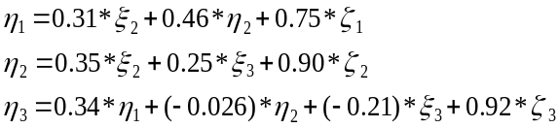

In terms of SMC, the brand explains 43% of the variance in price, product characteristics, and word-of-mouth. Word-of-mouth explains 19% of the variance in product characteristics and compatibility. Purchase intention for HVGC explains 17% of the variance in price, brand, word-of-mouth, and compatibility.

5.2 Model 1_{GLS}

The model 1_{GLS}, except for γ11, γ13, β13, β23, remainder of standardized path coefficients are founded significant determinant. It provides fit indices with GFI, AGFI, PGFI, RMR, RMSEA, CFI, and NFI values of 0.9, 0.85, 0.70, 0.16, 0.05, 0.70, and 0.55.

The structural equation model is formulated in following mathematic equations.

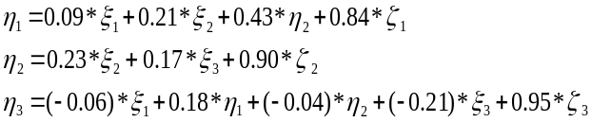
In terms of SMC, the brand explains 27% of the variance in price, product characteristics, and word-of-mouth. Word-of-mouth explains 8% of the variance in product characteristics and compatibility. The purchase intention on home video game console explains 8% of the variance in price, brand, word-of-mouth, and compatibility.

5.3 Mode 2_{ML}

The model 2 isn’t been considered because it is an insignificant determinant in preliminary test. Hence, we remove it temporarily and measure the performance. In model 2_{ML}, model fit indices reveal the value, with GFI, AGFI, PGFI, RMR, RMSEA, CFI, and NFI of 0.91, 0.86, 0.67, 0.08, 0.07, 0.90, and 0.85. The standardized path coefficients indicate that the product characteristics (γ21=0.31, p<0.01) has significant determinant on the brand and as well as (γ22=0.35, p<0.001) significant determinant on word-of-mouth, respectively. The compatibility (γ32=0.25, p<0.001) has significant determinant on word-of-mouth as well as (γ33=-0.210.35, p<0.05) significant determinant on purchase intention, respectively. The word-of-mouth communication (β21=0.46, p<0.001) has significant determinant on brand. The brand (β13=0.34, p<0.001) has significant determinant on purchase intention.

The structural equation model is formulated in following mathematic equations.

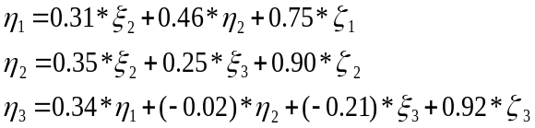

In terms of SMC, the brand explains 42% of the variance in price, product characteristics, and word-of-mouth. Word-of-mouth explains 18% of the variance in product characteristics and compatibility. The purchase intention on home video game console explains 13% of the variance in price, brand, word-of-mouth, and compatibility.

5.4 Model 2_{GLS}

In model 2_{GLS}, except for β23, remainder of standardized path coefficients are significant determinants. Results indicate that model fit indices are described with GFI, AGFI, PGFI, RMR, RMSEA, CFI, and NFI values of 0.92, 0.88, 0.69 0.13, 0.09, 0.79, and 0.65.

The structural equation model is formulated in following mathematic equations.

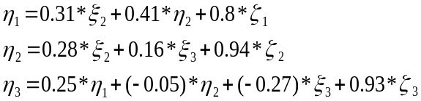

In terms of SMC, the brand explains 35% of the variance in price, product characteristics, and word-of-mouth. The word-of-mouth explains 10% of the variance in product characteristics and compatibility. The purchase intention for home video game console explains 12% of the variance in price, brand, word-of-mouth, and compatibility.

5.5 Model 3_{ML}

In model 3, the purchase intention has been associated with price, product characteristics, compatibility, word-of-mouth communication, and brand directly with linear relationship; on the other hand, it has no indirect effects. In the model 3_{ML}, it performs with GFI, AGFI, PGFI, RMR, RMSEA, CFI, and NFI values of 0.75, 0.66, 0.61, 0.17, 0.13, 0.56, and 0.52. In terms of GFI, and AGFI, it is not suitable relative model 1 and 2. It shows that only price (γ11=0.227 p<0.001) has significant determinant on purchase intention and the remaining of path coefficients haven’t. In terms of SMC, jointly, five exogenous latent variables explain 14% of the variance in purchase intention on home video game console in model 3_{ML}.

The structural equation model is formulated in following mathematic equations.

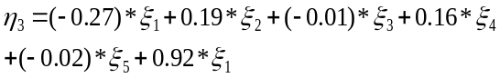

5.6 Model 3_{GLS}

In model 3_{GLS}, it performs with GFI, AGFI, PGFI, RMR, RMSEA, CFI, and NFI values of 0.85, 0.79, 0.69 0.23, 0.08, 0.42, and 0.35. It shows that all standardized path coefficient between variables have not found significant determinant. In terms of SMC, jointly, five variables explain 1% of the variance in purchase intention on home video game console in model 3_{GLS.} The structural model is formulated in following equation.

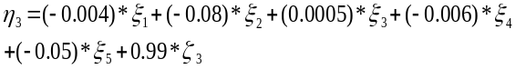

5.7 Model 4_{ML}

In model 4_{ML}, price is trimmed for validating the performance. The reason is the same as model 2 for trimming price. It performs with GFI, AGFI, PGFI, RMR, RMSEA, CFI, and NFI values of 0.86, 0.79, 0.68, 0.15, 0.09, 0.82, and 0.77 in model 4_{ML}. It shows hypotheses, except for the one between word-of-mouth and purchase intention, are found significant determinants. Hypothetical paths between product characteristics and purchase intention, between compatibility and purchase intention, between word-of-mouth and purchase intention, are all significant determinants, supporting the casual relationship between product characteristics toward purchase intention (γ21=0.32, p<0.001), compatibility toward purchase intention (γ31=-0.22, p<0.05), word-of-mouth communication toward purchase intention (γ41=-0.19, p<0.01). In terms of SMC; jointly, the four variables explain 20% of variances in purchase intention.

The structural equation model is formulated in following mathematic equation.

5.8 Model 4_{GLS}

In model 4_{GLS},, results indicate that the model fit indices perform with GFI, AGFI, PGFI, RMR, RMSEA, CFI, and NFI values of 0.91, 0.86, 0.70, 0.2, 0.06, 0.73, and 0.60. All hypotheses, except for the two between word-of-mouth communication and purchase intention; between brand and purchase intention, are significant determinant. In terms of SMC; jointly, the four factors explain 11% of variance in purchase intention.

The structural model is formulated in following mathematic equation.

5.9 Model Validation

The estimated models are tested to validate the plausible model. Three steps mentioned in 4-2 are employed in following validation.

In terms of significant determinant, the model 3_{ML}and 3_{GLS} are found an insignificant with 5 paths and 3 paths respectively. The model 4_{GLS} is also found an insignificant with 2 paths. Those are not satisfactory models for determining the purchase intention of home video game console relative to model 1, 2, and 4_{ML} that are found only one an insignificant path. Therefore, the model 3 and 4_{GLS} are not considered in the next step. The root mean residual (RMR) is been considered as measurable of the average of the residual. It can be used to compare the fit of two different models for the same data (Joreskog and Sorbom 1982). The model 1_{GLS}, 2_{GLS}, and 4_{ML} which perform the value above 0.1 are abandoned in terms of RMR.

Squared multiple correlations (SMC) is used to judge which one is superior in predicting purchase intention of home video game console. The model 1_{ML} [model 1_{ML}: SMC (PI) =17%] provides somewhat better SCM relative to model 1_{GLS}, and 2 [model 1_{GLS}: SMC (PI) =8%; model 2_{ML}: SMC (PI) =13%; model 2_{GLS}: SMC (PI) = 12%] except for model 4_{ML} [model 4_{ML}: SMC (PI) =20%]. However, the model 4_{ML} had already been abandoned in second step by means of the threshold of RMR. Overall, in terms of validation, results indicate that model 1_{ML} is superior in predicting purchase intention of home video game console in relative to others.

6. CONCLUSION

It demonstrates the model validation on the estimated models and reveals the causal relationships in this study. Each estimated model leads to different performances accounted for maximum likelihood (ML) and generalized least-squared (GLS). The plausible model is validated and be confirmed the previous hypotheses. But it is a little different with initial hypotheses derived from interviews.

In validated procedures, the model 1_{GLS}, 2_{GLS}, 3, and 4 shows more poorly than model 1_{ML} and 2_{ML} in terms of reasonable model fit indices, significant determinant, and square multiple correlations (SMC). We finally employ the model 1_{ML} to be the conceptual mode because professional players argues that price always plays the crucial role for purchase intention of home video game console. That is why model 2_{ML} is not considered in this study.

As stated in H_{4a} and H_{5a}, price is found to affect the purchase intention and the brand respectively. Two hypotheses are positive effect. The price is still a crucial factor in behavior research even if it is not significant in preliminary test. About pricing strategy, game consoles which have reasonable price can attract attention in retails (Ofir and Russell S. Winer 2002). In practice, price reduction is executed frequently when competition is overheated in game console sales. The significant impact of H_{5a} shows the brand is affected by price. The study argued the positive effect of price existed when brand name is present than absents (Monroe and Krishnan 1985) . It means consumers evaluate the brand and ask about one substantial question: how much is the brand worth.

The compatibility toward word-of-mouth communication and purchase intention respectively is significant determinant (H_{2a} and H_{3a}). A part of people desire to influence the purchase behavior when others seek advice for considering a new product (Flynn, Goldsmith et al. 1996). The people who share information about new products to others is known as opinion leader (Rogers 1995). They influence mostly purchase behavior in social network such as game magazine reviews. Most opinion leaders are knowledgeable about game console. They are very interested in product characteristics and give immediate suggestions for consumers (Venkatraman 1989; Rogers 1995). Hence, opinion leaders enable consumers change purchase behavior through word-of-mouth communication if compatibility as well as product characteristics (H_{6a}) are not good. The result also supports the H_{7a} which indicates the brand is affected by product characteristics. Consumers who have experience of game console realize clearly which brands usually have amazing product characteristics. Hence, they are boycotting the game console if the company is proficient in manufacturing product characteristics. It reduces the purchase intention once they have stereotyped image for the specific brand which is not good at product characteristics (H_{1a}).

It deserves to be mentioned that a causal relationship between compatibility and purchase intention is reversed. (i.e., the more compatibility on product we concerned on home video game console, the less purchase intention we have.) The reason is that the compatibility which company focuses on is unavailable such as whether to be compatible with previous software. The study argues that responses who have pirated digital material have a strong intention to use pirate software in the future (Timothy P. C. and Sulaiman A.R. 2008). In Taiwan, most of consumers have experience of pirate software usage. Most responses (82.5%) have experience to duplicate pirate software. They are lack of purchase intention due to unable to refit the game console even if it is not an illegal. It is common circumstances in Taiwan or elsewhere in the world. Therefore, whether to refit the game console is the major factor for purchase as to be compatible with pirate software. One of players interprets that game consoles which have compatible with other devices can’t bring satisfaction for most consumers. It is the contradiction that companies don’t want to confront the reality and undergoes loss market shares due to game consoles which are unable to refit.
The results supporting H_{9a} indicate brand is influenced by word-of-mouth (WOM) communication (H_{9a}). It reflects that brand switching may occur if opinion leaders spread the negative informatory about new products around (Richins 1983). The people seeks for diagnosis with opinion leaders that make feel ease to determine decision (Tybout, Sternthal et al. 2005) if they are less knowledge about new products even game consoles is the same. Under this circumstances, WOM communication (refers to opinion leaders) plays the significant role for determining the intention. The negative WOM communication counteracts the positive WOM communication when consumers purchase. It indicates that consumers pay more attention to be negative information than positive.
Unfortunately, only H_{8a} is not found the substantial impact. There are two reasons 1) the format on WOM communication is not vivid; it hard to evoke purchase intention (Herr, Kardes et al. 1991) and 2) it can’t review independently between WOM communication and purchase intention without consideration of price, product characteristics, and compatibility in this study. How to arouse intention through vividly information is the prime goal for company, not just print information related to game console function.
The results support H_{3a}, which shows the brand is affected positively by product characteristics. In other word, unfavorable product characteristics result in complaints in specific brand through WOM communication. The brand’s reputation is crippled if the company cares nothing at all. Consequently, the finding supports H_{6a} which indicates product characteristics are positive impact by WOM communication. It confirms the previous finding that opinion leaders have deep experience about product characteristics of new product and provide advices to consumers. The product manager must concentrate the product characteristics. It not only affects WOM communication but also influences the brand. In other word, NWOM communication leads to be brand switching immediately if the product manager ignores (Florian V W. and Tomas B. 2004).

REFERENCE

Augusto de Matos, C. and C. T. Ituassu, "Consumer Attitudes toward Counterfeits: A Review and Extension." Journal of Consumer Marketing VOL. 24, NO.1, pp36-47, 2007

Bennett, P. D. and G. D. Harrell, "The Role of Confidence in Understanding and Predicting Buyers' Attitudes and Purchase Intentions." Journal of Consumer Research, VOL. 2, NO. 2, pp110-117, 1975

Chernatony, L. D. and G. McWilliam, "Branding terminology the real debate." Marketing Intelligence & Planning, VOL. 7, NO. 7/8, pp29-32, 1989

Dhebar, A., "Complementarily, Compatibility, and Product Change: Breaking with the past?" Journal of Product Innovation Management, VOL. 12, NO. 2, pp136-152, 1995

Florian V W. and Tomas B., "The Effect of Word of Mouth on Services Switching: Measurement and Moderating Variables." European Journal of Marketing, VOL. 38, NO. 9/10, pp1173-1185, 2004

Flynn, L. R., R. E. Goldsmith, et al., "Opinion Leaders and Opinion Seekers: Two New Measurement Scales." Journal of the Academy of Marketing Science VOL. 24, NO. 2, pp137-147, 1996

Gray M. Erickson and J. K. Johansson, "The Role of Price in Multi-Attribute Product Evaluations." Journal of Consumer Research, VOL. 12, NO. 2, pp195-200, 1985

Herr, P. M., F. R. Kardes, et al., "Effects of Word-of-Mouth and Product-Attribute Information on Persuasion: An Accessibility-Diagnosticity Perspective." Journal of Consumer Research, VOL. 17, NO. 4, pp454-462, 1991

Howard, J. A. (1989). Consumer Behavior in Marketing Strategy. Englewood Cliffs, NJ, Prentice Hall.

Howard, J. A. and J. N. Sheth (1969). The Theory of Buyer Behavior. New York, Wiley.

J.C.;, A. and G. D.W., "Structural Equation Modeling in Practice: a Review and Recommended two-step approach." Psychological Bulletin, VOL. 103, NO. 3, pp459-489, 1988

Joreskog, K. G. and D. Sorbom, "Recent Developments in Structural Equation Modeling." Journal of Marketing Research, VOL. 19, NO. 4, pp404-416, 1982

Joreskog, K. G. and D. Sorbom (1996). Liserl 8: User's Reference Guide. Chicago, International Scientific Software

Lyman E. Ostlund, "Perceived Innovation Attributes as Predictors of Innovativeness." Journal of Consumer Research, VOL. 1, NO 2, pp23-29, 1974

Margherita, P., "A Vicarious Innovativeness Scale for 3G Mobile Services: Integrating the Domain Specific Innovativeness Scale with Psychological and Rational Indicators." Technology Analysis & Strategic Management, VOL. 19, NO. 6, pp709-728, 2007

Monroe, K. B. and R. Krishnan (1985). "The Effect of Price on Subjective Product Evaluations." Perceived Quality, Lexington Books, Lexington, MA: 209-32.

O'Guinn, T. C. and L. J. Shrum, "The Role of Television in the Construction of Consumer Reality." Journal of Consumer Research, VOL. 23, NO. 4, pp278-294, 1997

Ofir, C. and Russell S. Winer (2002). Pricing: Economic and Behavioral Models. in Handbook of marketing. Barton A. Weiz and Robin Wensley. London, Sage Publications.

Pagani;, M., "A Vicarious Innovativeness Scale for 3G Mobile Services: Integrating the Domain Specific Innovativeness Scale with Psychological and Rational Indicators." Technology Analysis & Strategic Management, VOL. 19, NO. 6, pp709-728, 2007

Patricia A. Goering, "Effects of Product Trial on Consumer Expectations, Demand, and Prices." Journal of Consumer Research, VOL. 12, NO. 1, pp74-82, 1985

Peter C.R., "Price-Quality Correlation for Packaged Food Products." Journal of Consumer Affairs, VOL. 13, NO. 2, pp236-247, 1979

Richins, M. L., "Negative Word-of-Mouth by Dissatisfied Consumers: A Pilot Study." Journal of Marketing, VOL. 47, NO. 1, pp68-78, 1983

Rogers, E. M. (1995). Diffusion of Innovations. New York, Free Press.

Rosemary R. Seva, Henry Been-Lirn Duh, et al., "The Marketing Implications of Affective Product Design." Applied Ergonomics, VOL. 38, NO. 6, pp723-731, 2007

Susan L. Holak, "Determinants of Innovative Durables Adoption: An Empirical Study with Implications for Early Product Screening." Journal Product of Innovation Management, VOL. 5, NO. 1, pp50-69, 1988
Susan L. Holak and D. R. Lehmann, "Purchase Intention and the Dimensions of Innovation: An Exploratory Model." Journal Product of Innovation Management, VOL. 7, NO. 1, pp59-73, 1990

Timothy P. C. and Sulaiman A.R., "Factors that Influence the Intention to Pirate Software and Media." Journal of Business Ethics, VOL. 78, NO. 4, pp 527-545, 2008

Tybout, A. M., B. Sternthal, et al., "Information Accessibility as a Moderator of Judgments: The Role of Content versus Retrieval Ease." Journal of Consumer Research, VOL. 32, NO. 1, pp76-85, 2005

Urbany, J. E., P. R. Dickson, et al., "Buyer Uncertainty and Information Search." Journal of Consumer Research, VOL. 16, NO. 2, pp208-215, 1989

Venkatraman, M. P., "Opinion Leaders, Adopters and Communicative Adopters: A Role Analysis." Psychology and Marketing, VOL. 6, NO. 1, pp51–68, 1989

2009-ICMSDM-TW.

