Purchase Intention Model for Video Game Consoles
John Sum, Mario Wei-ting Liao
Institute of E- Commerce, National Chung Hsing University
Taichung 40227, Taiwan.

Abstract

While Wii has introduced an easy-to-play control device, a new player groups has been attracted to play video games without spending time to learn how to control a complicated device. The market environment in video game consoles has shifted. A new understanding on purchase intention model will be needed. Therefore, a new model describing such relation is presented in this paper. After interviewing a group of professional players, variables leading to purchase intention are identified. They include price, product characteristics, compatibility, brand, and word-of-mouth. With survey on the related literatures regarding purchasing intention, a conceptual model for those variables towards purchasing intention is proposed and validated vigorously by statistical analysis on around 200 questionnaires collected. It is revealed that purchase intention is directly determined by price, compatibility, and brand imagine. Word-of-mouth shows positive effect on the brand of a game sole but no direct effect to the purchase intention. Product characteristic shows positive impact on the brand and word-of-month only. It does not have direct impact on the purchase intention. Furthermore, it is found that product characteristic and compatibility have strong relationship to word-of-month. Together with the finding that word-of-month has strong impact on the brand. It implies that professional players have a vital role in the game console market. Their understanding on the product characteristics and its compability is able to boost the purchase intention of a normal player.

Keywords: Competitive Analysis, Structural Equation Model (SEM), Purchase Intention, Video Game Console, Maximum Likelihood (ML) Estimation, Generalized Least-square (GLS) Estimation, Brand, Word-of-mouth Communication.

1. Introduction

Market development of home video game console has been an increasing concern since the first home video game console “Magnavox Odyssey” launched in 1972. Nowadays, the sale volume of home video game consoles has grown to $88 hundred million (iSuppli’s Report, 2008). In accordance with VGCHART.com, Nintendo Wii records 39 million sales in 2008. Microsoft XBOX360 records around 24 million and Sony PlayStation3 records around 18 million. The large sale volume of Wii reveals a new market segment that has not been aware by Microsoft and Sony: those who love to play with simple but interactive control. Thus, how to evoke purchase intention for home video game console and identify variables of concern to consumers owing to understand the current market environment will be inevitable.
The purchase intention for product derived from confidence behind the mind (Howard and Sheth 1969). It‘s greater chance to purchase the particular product if consumers feel confident. Hence, the confidence played the significant role in predicting intention (Bennett and Harrell 1975). The confidence served as subjective certainty to consumers in making decision of a particular product (Howard 1989). Simultaneously, in this study, we must investigate the composition of abstract concept of confidence. As another point of view, consumers made it estimatedto evaluate product in their ability that let them be confident in purchase product (Bennett and Harrell 1975). Confidence behind consumers’ mind could conceptualize knowledge confidence and choice confidence (Urbany, Dickson et al. 1989). The knowledge confidence means consumers can build up their confident by means of what is known about product. Based on past meaning and interviews, in this study, we proposed several variables which depicted product information in consumers’ purchase such as price (Gray M. Erickson and Johansson 1985), product characteristics (Lyman E. Ostlund 1974; Susan L. Holak 1988; Rosemary R. Seva, Henry Been-Lirn Duh et al. 2007), compatibility (Peter C.R. 1979; Susan L. Holak and Lehmann 1990; Dhebar 1995). On the other hand, choice confidence reflects a consumers’ certainty by means of which brand to choose. Hence, brand (Chernatony and McWilliam 1989) is definitely conceptualized into model of interest and the choice of brand is usually influenced through word-of-mouth communication (Patricia A. Goering 1985) and consequently, we postulate that word-of-mouth positively affects choice of brand in decision making of whether to buy or not.
In the empirical literature, the overall home video game console is often considered as strategies with other company or the content of home video game console. For example, from the perspective of company, it showed companies integrate with cartoon and animation film to develop popular home video game console for boosting market sales in Japan (Aoyama and Izushi 2003). It cared about the creative resource that brings out the prosperity of home video game console industry instead of consumers’ perspectives to discuss. Nevertheless, according to Cooper and Kleinschmidt (1991) estimated that new product launched to market in the failure rate was about 75%. Under this condition, how about enhance the chances of success for new product is the crucial issues. Under above mentioned, developing the general construct for purchase intention of home video game console from consumers’ perspective put on the front burner.
The majority of studies have concerned the intention employed structural equation modeling (SEM) toward mobile phone (Hans H. B. and Stuart J. B. 2005), wireless application protocol phone (WAP phone) (Kim; 2008), wireless LAN (Cheolho Y. and Sanghoon K. 2007) and so on. The past studies mentioned above are modified by means of technology acceptance model (TAM) for novel products
Unfortunately, no general model has been developed for video game console in marketing research. In this study, the ultimate objective is to (1) develop the general model, which investigates how to stimulate the consumers’ purchase intention from different viewpoints, (2) identify underlying variables, and (3) validate a causal relationship assumed by background survey and interviews. The primary objective of interest is not to refute the traditional theoretical framework but to provide clarity and enable marketing manager to align strategies under market condition.
TABLE 1-1:
The specification of home video game consoles in 2007
Console | Company | Launched in Taiwan | Processor | Memory | Connectivity | Media
Wii | Nintendo | November 19, 2006 | ATI”Hollywood” | 512 Internal Flash Memory Security Digital Card | Wi-Fi  Bluetooth  2 *USB2.0  LAN Adapter | 12 cm  Optical Disc
PlayStation3 | Sony | November 17, 2006 | 3.2GHz CellBroadband  Engine with 1PPE & 7 SPEs | 2.5” SATA HardDrive | Memory Stick  SD/MMC  Compact Flash | Blu-ray Disk  DVD  CD
XBOX360 | Microsoft | March 16, 2006 | 3.2GHz PPC Tri-Core Xenon | 64, 256 or 512 MB Memory Cards | 3 * USB2.0  IR Port  100M Bit Ethernet | DVD  DVD-DL

2. Background Survey
This section discusses the underlying variable and brief introduction of structural equation modeling (SEM) approach. We interview experienced players and ask questions related to purchase intention of home video game console. Those variables included price, product characteristics, compatibility, brand and word-of-mouth communication are explored based on literature review and interviews. Those variables are influenced purchase intention directly and indirectly in purchase decision.
2.1 Price
Price is one of the most important cues in marketplace. The views about price can be interpreted by economics and consumers. From economics perspective, price is represented as constraint to be trade-off products for each unit with maximum utility. No hidden information exists in exchanging products in marketplace. From the consumer’s perspective, price is described what kind of products you give up or sacrifice. The issue of price has been discussed as critical factor requiring consideration with limited budget on purchase intention (Gray M. Erickson and Johansson 1985) even in intrinsic attribute information (Mitra 1995). A set of acceptable price range is, for example, established when consumers purchase products. It is reduction on purchase intention when the actual price on products is higher than acceptable price range and vice versa (Dodds 1991). If the price is lower than acceptable price range seriously, consumers are lack of confidence on products (Peter; 1969).
With reference to Jacoby and Olson (1977), this paper argued that the price is a cue to simulate the consumer’s perception on purchasing products and the price can reflects psychology response on consumers mind after contacting price. Simultaneously, the attitude toward price can be integrated with other information. The consumer makes decision whether to buy the product or not based on integrated all information. It is a well-known model as simulate-organism-response model (S-Q-R Model). The price is a helpful cue to infer by consumer’s internal knowledge related to products (Gray M. Erickson and Johansson 1985). Similarly, Monroe and Krishnan (1985) prove Jacoby’s model in advance. It indicates that price standard is estimated by perceived quality and perceived sacrifice. It means high price results in high product quality and eventually enhances purchase intention directly (see Figure 2-1). In terms of Monroe’s concept, Lefkoff (1993) extended the role of price which influenced purchase intention, not only includes perceived quality but also perceived sacrifice.

FIGURE 2-1
An effect of price on personal subjective product evaluation
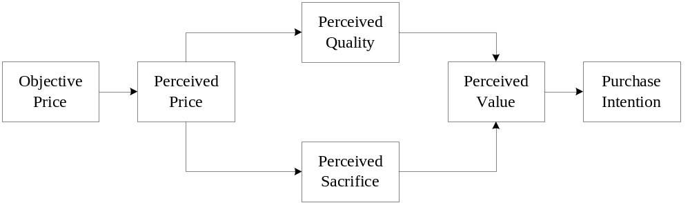
Source: Jacoby and Olson (1977); Gray M. Erickson and Johansson (1985);

About collections of prices data of 5th generation game consoles, this research indicates that the attractiveness of video game console is driven by price on PI in video game console industry (Chow; 2007). In other words, the lower price strategy is excessively available to enhance PI at beginning of product released. Both of prices on video game console and game software are considered (Prieger; and Hu; 2006). Hence, consumers aren’t willing to pay with higher price of video game software after purchasing cheaper video game console. Actually, consumers can be exploited by charging higher price on software.

2.2 Compatibility
Compatibility as introduced by Roger (1983) is associated with how the product fit with consumers’ behavior patterns, life-styles and values. It will be receivable if video game console compatible with consumer’s life-style and needs, therefore, it will be preferred over alternative video game console. A large stream of researches related to the compatibility on technology product can prove that consumers are willing to receive compatible products (Peter C.R. 1979; Susan L. Holak and Lehmann 1990; Dhebar 1995; Dhebar 1995). Findings indicate that compatibility is represented as a measurable indictor on purchase intention for durable and non-durable technology products (Peter C.R. 1979) such as solar energy (Labay and Kinnear 1981). To examine 190 adults of consumption experience, this research finds that experience is influenced by mixtures of effort, lifestyle compatibility, and enjoyment (Dillon; and Reif; 2006).
What kinds of indicator have to measure compatibility is an essential to be concerned on purchase intention. In 1995, Dhebar proposes three criteria to measure the compatibility including switching cost (Castaño, Sujan et al. 2008), learning cost (Astebro; 2004), and the complementary product (see Figure 2-2). Compatibility is used to infer learning cost when new features add technological products (Ashesh Mukherjee and Hoyer 2001). The purchase intention enhances if perceived value using technological product is higher than out-of-data products. In the other words, total of cost is too small to be considerable after using current products. For example, with respect to complementary, Sony Ltd. launched video game console to be successful because of higher compatible complementary. It can compatible with upward game software version on new video game console.
In the meantime, complementary has been concerned with three components, including database, other products, and user. Those components shall collaborate with each others. To summarize the previous researches that compatibility is not associated with products but also consumer’s habits.

FIGURE 2-2
An effect of compatibility on subjective product evaluation
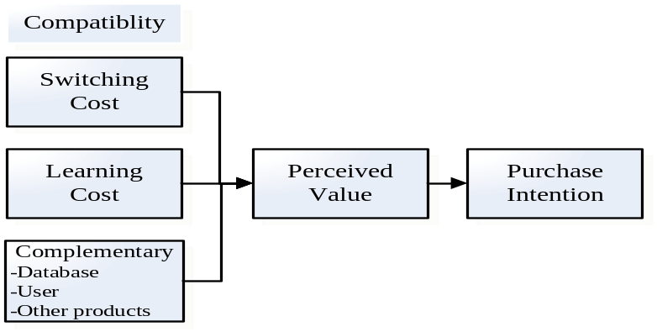
Source: Dhebar (1995), Roger (1983), Holak and Lehmann (1990)
2.3 Brand
Brand is a substantial effect on purchase decision making when product quality is uncertainty (Chu;, Choi; et al. 2005). Hence, a brand that consumers trust will reduce the perceived risk and post-purchase cognitive dissonance on specific product (Nandan; 2005). The brand is a collection of name, term, and symbol representing producer and is determined as being distinguishable from other corporations (Kolter 1999). Similarly, brand is represented as consumers’ self-image reflection, quality guarantee, product information representation and purchase measurable tool (Chernatony and McWilliam 1989).
Actually, the consumer is used to form product characteristics related to various brand through prior knowledge toward a high-tech product (Donnelly 1973; Rao and Sieben 1992; Grewal, Krishnan et al. 1998). If consumers can search enough information related to innovation product in their mind, so that purchase intention (PI) will enhance. Similarly, each brand can be recognized by consumers in terms of personal experience (Kolter 1999) and memory (Wyer and Srull; 1989). Besides, Keller (1993) validated that brand is served as an association or perception linked with product on the memory in purchasing decision making. Hence, more than two stages related to brand selection were established to simplify complicated process toward comparison of products in consumers’ mind (Kardes, Kalyanaram et al. 1993). The selection process is composed of three stages (1) retrieval (R), (2) consideration (C), and (3) choice (Ch). The retrieval stage is described that impressive brands are remaining after scrutinizing all emergence brand in consumers’ mind and then retain considerable brands from impressive brands-it’s consideration stage. Eventually, in choice stage, a specific brand can be selected within considerable brands (see Figure 2-3). Hence, the empirical study indicated that lots of experience consumers have is actually to be reduced considerable brands and choice the final brand (Moorthy, Ratchford et al. 1997).
FIGURE 2-3
The brand selection processes
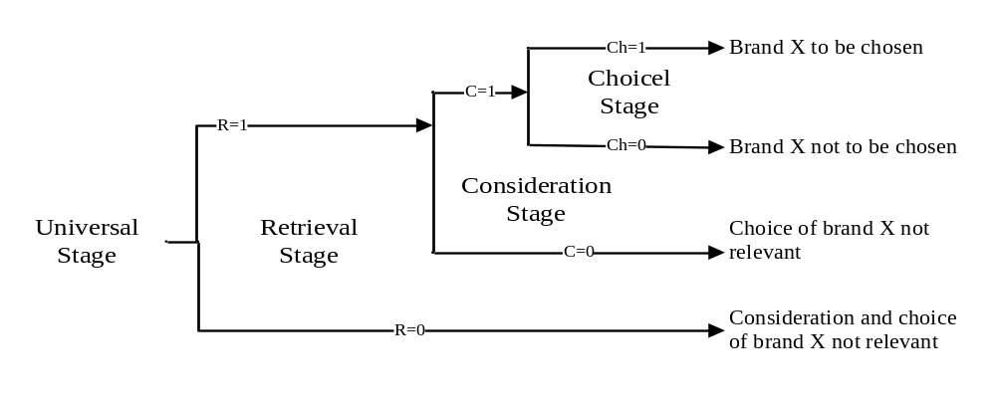
Source: Kardes, Kalyanaram et al. (1993)

It is worth mentioning that brand image is associated with brand. It has been recognized as an important concept in marketing (Gardner and Levy; 1955). The definition of brand image is served as a perception about a brand reflected by the brand associations held in consumers’ memory (Newman 1957). The empirical study indicates that a brand reflects diversified images of product, user, and corporate (Biel 1992). Hence, the brand image is dependent on the extent of understanding the product. The brand cognitive is associated with brand image and can be measured by brand image (Nandan; 2005). The more brand cognitive consumers have, the more PI will increase because consumers are going to understand the product related to user and corporate before purchasing (see Figure 2-4) (Dodds, Monroe et al. 1991). In other words, brand image is an excellent for consumers and PI will enhance.

FIGURE 2-4
The relationship between brand and purchase intention
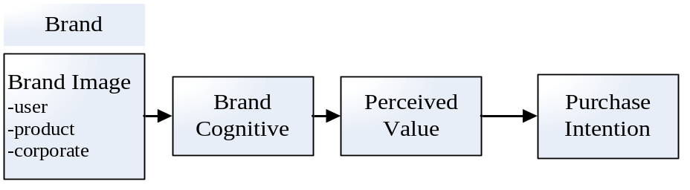
Source: Gardner and Levy (1955); Biel (1992); Nandan (2005)

2.4 Product Characteristic
In marketing, product characteristic is used to measure purchase intention (Lyman E. Ostlund 1974; Susan L. Holak 1988; Rosemary R. Seva, Henry Been-Lirn Duh et al. 2007). On typology about product characteristics is classified three fundamental types” (1) product property, which can be touched or described physical properties in reality such as product weighs, (2) product benefits provided function and utility from product such as Wii with connecting internet to exchange game treasures, and (3) product image that how the product symbolized the user to others or by himself (herself) such as PS3 with high-requirement of processing equipment (Lefkoff-Hagius and Mason 1993).
In comparison process of products, product characteristics is used to measure products of interest in terms of consumers’ knowledge; i.e. consumers compare with HVGC in terms of knowledge across brand for accurate decision (Mantel and Kardes 1999). Besides, the product with particular product characteristics can be attractive in comparison processes and influences purchase intention (Dhar and Sherman 1996). The reason is that PC enable to influence consumers’ emotion in product design (Dhebar 1995). For instance, consumers who hold cell-phone with large display are amazement and encouragement because subtitles can display clearly on large screen. Consumers not only purchase particular products but also for satisfaction of how products provide beneficial or self-image for desired group (Sirgy 1982).

2.5 Word- of-Mouth Communication
The word-of-mouth (WOM) communication is used to communicate the product (and services) information among consumers (Robert East, Kathy Hammond et al. 2007). Several studies indicate that WOMC is not only a significant role on purchase intention (Whyte, 1954; Bansal, H.S. and Voyer, P.A., 2000; Godes D., and Mayzlin, D., 2004), but also plays an important role on consumer behavior (Reynolds and Arnold 2000). The WOM communication provides the two-way communication immediately related to product information (Herr Paul M., Kardes Frank R et al. 1991). An effect of WOM communication is driven through new technologies, e-mail, internet, cell-phone, instant message(IM) (Dee T. Allsop, Bryce R. Bassett et al. 2007), and blog (Gilbert;, Jager; et al. 2007). All possible channels are to generate positive product assessment through WOM communication. The essence of WOM communication is based on individual favorite relative to utilitarian in nature (Cindy M. Y. Chung and Darke 2006). Benefits will be shared with other based on personal favorite after using products (Meyerowitz BE and S.; 1987; Maheswaran and Meyers-Levy 1990).
In decision making, the purchase intention is governed by WOM recommendation sources is (Patricia A. Goering 1985). The WOM recommendation source comes from: (1) strong-ties such as family and closed friends, and (2) weak-tie such as an expert (Jacqueline J.Brown and Reingen 1987). The advantage of weak-tie recommendation is to provide rich information without limitation compared with strong-tie because weak-tie enables to collect diversified information by way of particular channels that strong-tie ignore, such as the product test report of internal corporate.
The negative word-of-mouth (NWOM) communication is created with negative messages related to product through interpersonal channels. NWOM communication has a potential influence than professional consumer report. The reason is personal recommendation is accessible to memorize on purchasing a product of interest and diagnostic (Herr Paul M., Kardes Frank R et al. 1991). When product involvement is high and NWOMC can influence purchase intention than positive word-of-mouth (PWOM) communication and vice versa (Maheswaran and Meyers-Levy 1990). Brand, market share and market efforts are affected by PWOMC (Bayus 1985).

3. Methodology

This research is conducted by 6 steps. In Step 1, determining variables for purchase intention must be identified. Professional players who have been played HVGC for many years are interviewed and asked about what variables leading in purchasing intention.
In Step 2, items will be iterative designed in terms of interviews and the background survey. All items were designed to measure the interaction between variables and subjected to the six underlying variables. And then data collection came from students and consumers, who have experienced of Microsoft XBOX360, Nintendo Wii, and SONY PS3. Approximation of 100 questionnaires was collected in the 1st round.
In Step 3, the questionnaire is modified and the conceptual model is proposed. In the final design, 18 items were retained and tapped into 6 variables in the questionnaire. Then, the questionnaires are distributed to students, players and consumers of video game consoles. After all, 250 questionnaires are collected. The demographic characteristics of the respondents are depicted in Table 3-1. After preliminary analysis on a small sample, a structural equation model (SEM) is obtained used for modeling the relationship.
TABLE 3-1
Demographic characteristics of the respondents
Characteristics |  | N=250 | Percentage %
Gender
Male |  | 162 | 64.8
Female |  | 88 | 35.2
Age
Under 20 |  | 25 | 10
21-30 |  | 190 | 76
31-40 |  | 35 | 14
Years of experience on HVGC
Under 1 |  | 34 | 13.6
2-5 |  | 46 | 18.4
6-10 |  | 115 | 46
Above 11 |  | 55 | 22
Occupation
Student |  | 172 | 68.8
An employee in private enterprise |  | 26 | 10.4
An employee in government |  | 10 | 4
Freelance |  | 36 | 14.4
Experts in VCG |  | 6 | 2.4
Range of reasonable price on HVGC
Under 5,000 |  | 48 | 19.2
5,000~10,000 |  | 178 | 71.2
11,000~15,000 |  | 10 | 4
16,000 or above |  | 6 | 2.5
The HVGC that you have played ever
Nintendo Super Family Computer |  | 217 | 86.8
Nintendo Super Famicom |  | 174 | 69.9
Nintendo 64 (N64) |  | 135 | 54
Nintendo Wii |  | 178 | 71.2
Sega Dreamcast |  | 45 | 18
Sega MegaDrive |  | 101 | 40.4
SONY Playstation 1 |  | 219 | 87.6
SONY Playstation 2 |  | 92 | 36.8
SONY Playstation 3 |  | 47 | 18.8
Microsoft XBOX |  | 149 | 59.6
Microsoft XBOX 360 | 132 |  |  | 52.8

In Step 4, statistical analysis on 250 samples on the conceptual model is conducted. The model is assessed in terms of model fit indices, including goodness of index (GFI), adjusted goodness of index (AGFI), parsimonious goodness-of-fit index (PGFI), root mean squared error of approximation (RMSEA), root mean residual (RMR), comparative fit index (CFI), and normed fit index (NFI). Owing to avoid bias results, two parametric estimation methods (maximum likelihood (ML) and generalized least-squared (GLS)) are applied and compared. ML is assumed that distribution is known, and samples come from single independent class. Samples with observed items are followed Gaussion distribution. In contrast, the GLS is assumed the distribution of samples is followed non-Gaussion (O'Guinn and Shrum 1997; Augusto de Matos, Ituassu et al. 2007; Margherita 2007; Pagani; 2007)
In Step 5, competitive analysis on three alternative models is conducted. Again, two parametric estimation methods are applied to each alternative model to eliminate bias. Their assessment indices are compared with the assessment indices obtained in Step 4 for the proposed model.
In Step 6, in terms of indices introduced in comparison procedures, the plausible model would be explained the causal relationship from model comparison and implication for manager.

4. Model Conceptualization

In this paper, H₀ is represented as “all variable haven’t significant an impact on purchase intention of home video game console.” In the following, alternative hypothesis would be established in the light of background survey and opinions of professional players.
Brand is relative important than country-of-origin on searching and experience with product quality (d' Astous and Ahmend 1992; d’Astous and Ahmed 1992; Thakor and Katsanis 1997). Rao (1992) and Grewal (1998) indicate that high-knowledgeable consumers always recognize product quality based on brand compared with low-knowledge consumers. High quality, well-known brand, and preference store are prime concerned as cue for purchase. Obviously, the product with well-known brand must to be equipped with high compatibility for other product. Compatibility is one of crucial factors to make product effective working (Labay and T. C. Kinnear 1981). On the side, the novel product must be compatible with user’s behavior of the past (Susan L. Holak 1988). Further, a product of good compatibility is associated with switching cost, learning cost and a complementary product (Dhebar 1995) Several professional players argue that compatibility will be influenced by word-of-mouth (WOM) communication in interview. The disappointing information will, for instance, be spread through WOM communication if Microsoft XBOX360 is unable to be compatible with the previous games of Microsoft XBOX. Previous evidences are summarized in following alternative hypotheses.

H1a: The brand has a positive significant impact on purchase intention of home video game console.
H2a: The compatibility has a positive significant impact on purchase intention of home video game console.
H3a: The compatibility has a positive significant impact on WOM communication.

Previous empirical studies indicate that retail price (or price with promotion) is an efficient strategy in demand than other marketing-mix strategies (Elrod Erry and Russell S. Winer 1982; Guadani Peter M. and Little John D.C. 1983) (i.e. No matter how the price of product changes before and after promotion, lower price seems to be efficient to increase purchase intention.) In marketing, the price is an important factor (Mitra 1995), forecasting consumers’ demand (Gray M. Erickson and Johansson 1985) and inferring product quality based on price cue (Ruby Turner Morris and Bronson 1969; Morris and Claire S.B. 1970; Sproles 1977). With reference to Ostlund (1974), it indicates that it is easier for predicting the rate of adoption than for predicting adoption (or non-adoption) by individual. The product adoption is accomplished when purchase intention (or consumers’ satisfaction (Dhebar 1995) is higher. Hence, the purchase intention can be predicted through product characteristics (Lancaster 1966). Obviously, product characteristic serves as an indicator to predict consumers’ adoption (Philip Gendall, Janet Hoek et al. 2006). Besides, in complicated social network, interaction among consumers is omnipresent. Consumers notify of (un) favorable product characteristics or individual normative assessment on product and brand by word-of-mouth (WOM) communication (Gilbert;, Jager; et al. 2007). In interviews, professional players indicate the brand is likely to be influenced with product characteristics. A part of company of well-known brand is capable of manufacturing high-standard components inside HVGC compared with lower-standard components. All preceding evidences are summarized in the following alternative hypotheses.

H_{4a}: The price has a positive significant impact on purchase intention of home video game console.
H_{5a}: The product characteristic has a positive significant impact on purchase intention of home video game console.
H_{6a}: The product characteristic has a positive significant impact on word-of-mouth (WOM) communication.
H_{7a}: The product characteristics has a positive significant impact on brand..

Consumers are willing to provide WOM communication with friends and family based on their favorite products and is more persuasive than printed formation (Herr Paul M., Kardes Frank R et al. 1991). In contrast, an effect of WOM communication can be offset by negative WOM communication because of reduction of perceived value on product and influences purchase intention. In interviews, professional players indicate that brand can be influenced by WOM communication. In empirical studies of consumers’ attitude for favor brand is formed on the basis of single, favorable WOM communication, even when extensive, diagnostic attribute information is also available (Herr Paul M., Kardes Frank R et al. 1991). Infamous information about company will be spread through WOM communication and WOM helps consumers whether or not to buy this product of company in making decision (Zeithaml;, Berry; et al. 1993; Lundeen and Harmon 1995). In this sense, negative WOM (NWOM) communication may change consumers’ perception for original brand that they support and then switch another brand. All preceding evidences are summarized in following alternative hypotheses.
H_{8a}: The WOM communication has a positive significant impact on the brand.
H_{9a}: The WOM communication has a positive significant impact on purchase intention
FIGURE 4-1
The conceptual model for purchase intention of home video game console

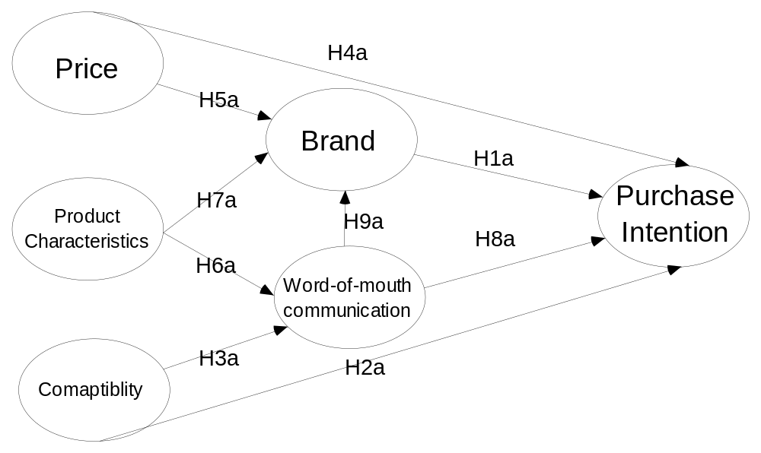
5. Statistical Analysis
5.1 Scale Reliability & Validity
Measuring the reliability and validity is an essential when we use structural equation modeling (SEM) approach. The standardized factor loading and accompanying significant determinants must be estimated. All items are in accordance with the rule which factor loading must be reached 0.5 or above (J.C.; and D.W.; 1988). In contract, items of factor loading less 0.5 shall delete before following test, so as to ensure that construct validity and composite reliability are satisfactory value.
In processes of refining the scale, problems occur that a part items is less than psychometric properties; i.e., their contribution of item are influenced by dimensions of construct. Simultaneously, we decide to narrow the domain of coverage of price, brand, and word-of-mouth communication of construct to refine appropriate scale. For example, the original items toward price attempts to capture all cues related to brand name, as well as other items that might contribute to overall price of construct (e.g., the range of product’s price or pre-use the “cheaper” than other video game console). But factor analysis indicates only three items with high factor loadings enable be represents as price of construct. Items 1, 3, and 6 shall be deleted.
For instance, the initial items related to brand attempt to capture information concerning whether the brand is represented as symbolic brand image and risk when consumers use the product, as well as other items that may contribute to brand (e.g., high market-share of brand, or the brand of product that has been used). The result reflects only item 1, 2, and 3 are acceptable in terms of loading above 0.5.
The items pertaining to this study measures a total of 18 items after factor loading test: three items referred to price, three items related to product characteristics, three items referred to compatibility, three items related to brand, three items referred to word-of-mouth communication, and three items related to purchase intention. Total of 14 items are deleted due to factor loading on each variable. Responses are required to fill in panes using five-point Likert scale, where 1 serves as “strongly disagree” and 5 serves as “strongly agree” (see Appendix).
It is necessary for measuring the reliability on variables. The reliability in terms of composite reliability (Hair, Anderson et al. 1998; Michael S. G. and John T. M. 1999) and the validity in terms of average variance extracted. Those are used to measure the reliability and validity of construct. The composite reliability measures an internal consistency of items on the each variable and is estimated by taking the square of sums for standardized factor loading (λ_{y}) divided by the square of sums for standard factor loading (λ_{y}) plus sums for standard error.
The average variance extracted measures the total variance in the indicators estimated by the latent variable (i.e., it’s employed to measure discriminant validity and is estimated by taking account of the square of sums of standard factor loading (λ_{y}) divided by the square of sums of standard factor loading (λ_{y}) added with sum of standard error.
The mathematical equation of composite reliability and average variance extracted show in the following:
Composite Reliability: 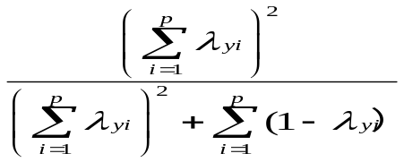
Average Variance Extracted: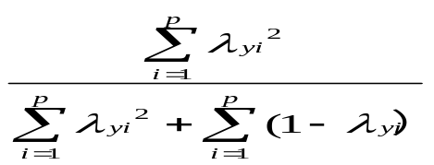

The value of composite reliability exceeded 0.7 is acceptable (Hair, Anderson et al. 1998). It reflects the construct reliability is consistent with high-internal consistency on each variable. The composite reliability is an acceptable value with price, product characteristics, compatibility, word-of-mouth communication, brand, and purchase intention of 0.83, 0.96, 0.95, 0.90, 0.90, and 0.92 (see the Table 4-1). All variables shows composite reliability in excess of the 0.7 recommended value (Hair, Anderson et al. 1998). The average variance extracted exceeded 0.5 is a satisfactory value (Fornell; and Larcker; 1981; Michael S. G. and John T. M. 1999). It reflects that the scale has high discriminat validity on conceptual model of interest. The value of average variance extracted are reached 0.7 recommended value with price, product characteristics, compatibility, word-of-mouth, brand, and purchase intention of 0.77, 0.90, 0.86, 0.74, 0.75, and 0.79.
TABLE 5-1
Standardized factor loading, internal composite reliability and average variance extracted of the scale
Variables and items | Construct reliability and validity
Variables and items | Standardized Factor Loading | Composite  Reliabilities | Average Variance Extracted
Price
P1 | 0.53 | 0.83 | 0.77
P2 | 0.75 | 0.83 | 0.77
P2 | 0.69 | 0.83 | 0.77
Product Characteristics
PC1 | 0.85 | 0.96 | 0.90
PC2 | 0.82 | 0.96 | 0.90
PC3 | 0.59 | 0.96 | 0.90
Compatibility
C1 | 0.76 | 0.95 | 0.86
C2 | 0.70 | 0.95 | 0.86
C3 | 0.56 | 0.95 | 0.86
Brand
B1 | 0.80 | 0.90 | 0.75
B2 | 0.87 | 0.90 | 0.75
B3 | 0.74 | 0.90 | 0.75
Word-of-mouth Communication
WOM1 | 0.76 | 0.90 | 0.74
WOM2 | 0.76 | 0.90 | 0.74
WOM3 | 0.81 | 0.90 | 0.74
Purchase Intention
PI1 | 0.73 | 0.92 | 0.79
PI2 | 0.80 | 0.92 | 0.79
PI3 | 0.84 | 0.92 | 0.79
Note: Responses to the items in all variables are measured on a 5-point Likert-tpye scale (ranging from 1=”strongly disagree” to 5=”strongly agree”).

5.2 Preliminary Test and Model Fit Indices
The structural equation modeling (SEM) applied SAS 8.0 estimated parameters among variables. As seen in Figure 4-1, the path coefficient among variables would be marked and shown the significant determinants. In conceptual model of interest, latent exogenous variables are composed of price (ξ₁), product characteristics (ξ₂), and compatibility (ξ₃). Latent endogenous variables are composed of brand (η₁), word-of-mouth communication (η₂), and purchase intention (η₃). Each variable is measured by three items directly.
FIGURE 5-1
The preliminary results
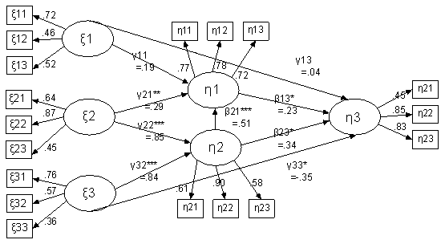Note: A “*” symbol in path corresponds the level of significant. * denotes that the path is significant at p<0.05. “**” denotes that the path is significant at P<0.01. “***” denotes that path is significant at P<0.001.

Several model fit indices which are widely used to describe the performance of structural equation modeling (SEM) are introduced here. In SEM, the goodness of fit index (GFI) and adjusted goodness of fit index are best known absolute index. The absolute index employs as part of the computation of sample covariance matrix and estimated population matrix derived from the model being test. The acceptable value is 0.9 or above for GFI (Tanaka and Huba 1984; Joreskog and Sorbom 1996) and AGFI (Joreskog and Sorbom 1996). The parsimony goodness of fit index (PGFI) associated with GFI is to validate the alternative model. It multiplies the respective parsimony ratio of the degrees of freedom (Mulaik, James et al. 1989). The PGFI’s value above0.5 is acceptable.
The incremental fit index are formed of normed fit index (NFI) (Bentler and Bonett 1980) , comparative fit index (CFI) (Bentler 1990), and root mean squared error of approximation (RMSEA) (Steiger 1990). The NFI measures that the tested model compared with baseline model which assumes each variable are uncorrelated. The NFI is available because it overcomes the inherent problems of the chi-squared analyses: sample size. The CFI evaluates the difference of non-centrality between estimated model and baseline model (Bentler 1990). In CFI cutoff, the value of 0.9 or above is the acceptable for determining appropriate model. The residual derives from the elements of the matrix that the sample covariance matrix substrates covariance estimated from model (Joreskog and Sorbom 1996). In practice, the RMR’s value closed to zero reflects that the discrepancy is little between sample covariance and model-implied covariance matrix. The RMSEA has been developed to measure the estimated model how close to fit in the population (Steiger 1990).
In the preliminary results, the performance is shown with GFI, AGFI, RMR, RMSEA, CFI, and NFI values of 0.82, .079, 0.11, 0.07, 0.80, and 0.75. In Figure 4-1, two paths which indicate between price and brand and between price and purchase intention isn’t found the significant determinants. The price is eliminated temporarily after discussing with professional players. We validate the estimatedmodel concluded price and non-price; respectively, estimate by maximum likelihood (ML) and generalized least-squared (GLS). Last, the plausible model will be validation.

5.3 Model Identification and Performance
Before model identification, Table 4-2 lists estimated model and estimates by maximum likelihood (ML) and generalized least-squared (GLS) respectively.
In following identification procedure, those estimated models are independently tested and are validated. Identification are followed the SEM approach. To identify models, three steps must perform. First, the path coefficient must reach significant determinant which represents as one asterisk (*) for the 0.05 significant determinant, two asterisk (**) for the 0.01 significant determinant and three asterisk (***) for the 0.001 significant determinant. Once the validated model has two insignificant paths or above, in this study, we abandon it. Second, multiple fit indices provides the cutoff for determining the appropriateness of estimated model. Fit indices offer the threshold to determine the satisfactory model. For example, GFI and AGFI introduced by Joreskog and Sorbom in 1985 is an important index to validate the model for small sample (Steiger 1990).
Finally, it must consider the interpretation as the proportion of variance in endogenous latent variables accounted for exogenous latent variables. This is well-known squared multiple correlations (SMC) (also known as explanatory power) (Rust, Lee et al. 1995). The fit indices, significant determinant, and SMC are to be equivalent; finally, the plausible model is validated.
TABLE 5-2
The model path and theoretical models to be tested
Path | Model 1 Model 2
Model: 1, 2 | 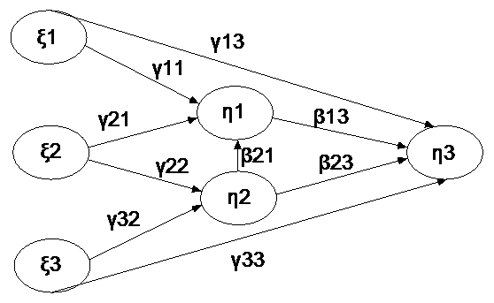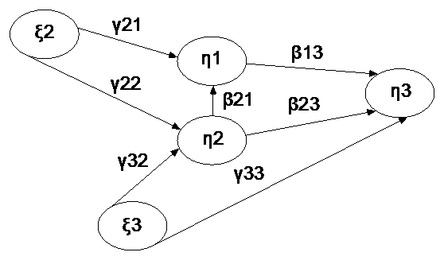  Model 3 Model 4  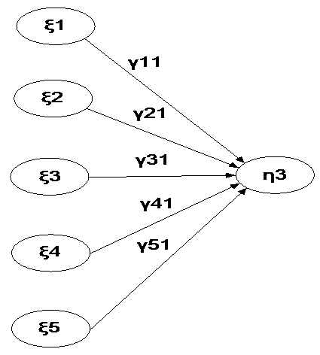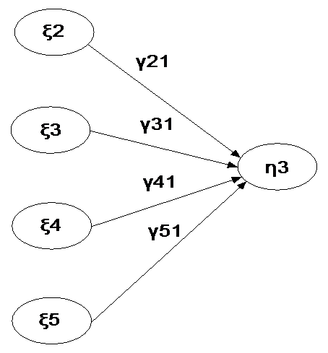
γ11 (Price → Brand)
γ13 (Price →Purchase intention)
γ21 (Product Characteristics →Brand)
γ22 (Product Characteristics →Word-of-mouth Communication)
γ33 (Compatibility→ Purchase Intention)
γ32 (Compatibility →Word-of-mouth Communication)
β13 (Brand → Purchase Intention)
β21 (Word-of-mouth Communication →Brand)
β23 (Word-of-mouth Communication→ Purchase Intention)
Model 3,4
γ11 (Price → Purchase Intention)
γ21 (Product Characteristics →Purchase Intention)
γ31 (Compatibility → Purchase Intention)
γ41 (Brand →Purchase Intention)
γ51 (Word-of-mouth Communication→ Purchase Intention)
Model fit indices | GFI, AGFI, PGFI, RMR, RMSEA, CFI, NFI

5.3.1 Model 1_{ML}
The model 1 is estimated by ML and GLS respectively as same as model 2, 3 and 4. Model 1_{ML} provides acceptable values, with goodness of fit index (GFI), adjusted goodness of fit index (AGFI), parsimonious goodness-of-fit index (PGFI), root mean residual (RMR), root mean squares error of approximation (RMSEA), comparative fix index (CFI) and normed fit index (NFI) values of 0.89, 0.84, 0.70, 0.10, 0.07, 0.86, and 0.79 (see Table 4-4 ).
It shows the standardized path coefficients in Figure 4-2. Results indicates the price (γ13=0.26, p<0.01) has significance determinant on purchase intention and (γ11=0.22, p<0.01) has significant determinant on bran. The product characteristics (γ21=0.25, p<0.01) has significant determinant on brand as well as significant determinant (γ22=0.35, p<0.001) on word-of-mouth communication. The brand (β13=0.22, p<0.05) has significant determinant on purchase intention. Nevertheless, word-of-mouth has not significant determinant on purchase intention. The compatibility (γ32=0.25, p<0.001) has significant on word-of-mouth and (γ33=-0.21, p<0.05) brand. The word-of-mouth (β21=-0.47, p<0.001) has significant impact on brand. Unfortunately, the word-of-mouth is not found the significant determinant on purchase intention.
The structural equation model is formulated in following mathematic equation.

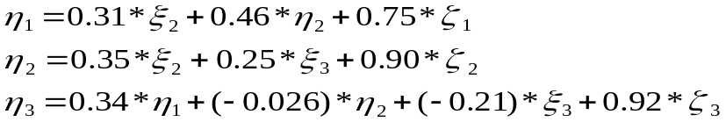

In terms of SMC, the brand explains 43% of the variance in price, product characteristics, and word-of-mouth. Word-of-mouth explains 19% of the variance in product characteristics and compatibility. Purchase intention for HVGC explains 17% of the variance in price, brand, word-of-mouth, and compatibility.

5.3.2 Model 1_{GLS}
The model 1_{GLS}, except for γ11, γ13, β13, β23, remainder of standardized path coefficients are founded significant determinant (see Figure 4-3). It provides fit indices with GFI, AGFI, PGFI, RMR, RMSEA, CFI, and NFI values of 0.9, 0.85, 0.70, 0.16, 0.05, 0.70, and 0.55 (see Table 4-4).
The structural equation model is formulated in following mathematic equations.

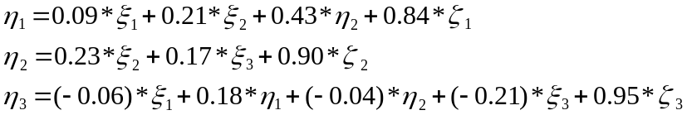
In terms of SMC, the brand explains 27% of the variance in price, product characteristics, and word-of-mouth. Word-of-mouth explains 8% of the variance in product characteristics and compatibility. The purchase intention on home video game console explains 8% of the variance in price, brand, word-of-mouth, and compatibility.

5.3.3 Mode 2_{ML}
The model 2 isn’t been considered because it is an insignificant determinant in preliminary test. Hence, we remove it temporarily and measure the performance. In model 2_{ML}, model fit indices reveal the value, with GFI, AGFI, PGFI, RMR, RMSEA, CFI, and NFI of 0.91, 0.86, 0.67, 0.08, 0.07, 0.90, and 0.85 (see Table 4-4). In Figure 4-4, the standardized path coefficients indicate that the product characteristics (γ21=0.31, p<0.01) has significant determinant on the brand and as well as (γ22=0.35, p<0.001) significant determinant on word-of-mouth, respectively. The compatibility (γ32=0.25, p<0.001) has significant determinant on word-of-mouth as well as (γ33=-0.210.35, p<0.05) significant determinant on purchase intention, respectively. The word-of-mouth communication (β21=0.46, p<0.001) has significant determinant on brand. The brand (β13=0.34, p<0.001) has significant determinant on purchase intention.
The structural equation model is formulated in following mathematic equations.

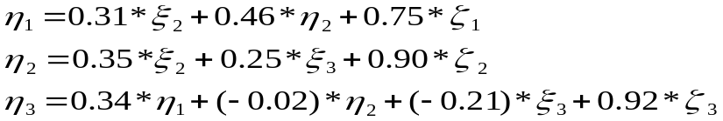

In terms of SMC, the brand explains 42% of the variance in price, product characteristics, and word-of-mouth. Word-of-mouth explains 18% of the variance in product characteristics and compatibility. The purchase intention on home video game console explains 13% of the variance in price, brand, word-of-mouth, and compatibility.

5.3.4 Model 2_{GLS}
In model 2_{GLS}, except for β23, remainder of standardized path coefficients are significant determinants (see Figure 4-5). Results indicate that model fit indices are described with GFI, AGFI, PGFI, RMR, RMSEA, CFI, and NFI values of 0.92, 0.88, 0.69 0.13, 0.09, 0.79, and 0.65 (see Table 4-4).
The structural equation model is formulated in following mathematic equations.

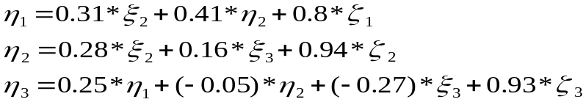

In terms of SMC, the brand explains 35% of the variance in price, product characteristics, and word-of-mouth. The word-of-mouth explains 10% of the variance in product characteristics and compatibility. The purchase intention for home video game console explains 12% of the variance in price, brand, word-of-mouth, and compatibility.

5.3.5 Model 3_{ML}
In model 3, the purchase intention has been associated with price, product characteristics, compatibility, word-of-mouth communication, and brand directly with linear relationship; on the other hand, it has no indirect effects. In the model 3_{ML}, it performs with GFI, AGFI, PGFI, RMR, RMSEA, CFI, and NFI values of 0.75, 0.66, 0.61, 0.17, 0.13, 0.56, and 0.52 (see Table 4-5). In terms of GFI, and AGFI, it is not suitable relative model 1 and 2. In Figure 4-6, it shows that only price (γ11=0.227 p<0.001) has significant determinant on purchase intention and the remaining of path coefficients haven’t. In terms of SMC, jointly, five exogenous latent variables explain 14% of the variance in purchase intention on home video game console in model 3_{ML}.
The structural equation model is formulated in following mathematic equations.

5.3.6 Model 3_{GLS}
In model 3_{GLS}, it performs with GFI, AGFI, PGFI, RMR, RMSEA, CFI, and NFI values of 0.85, 0.79, 0.69 0.23, 0.08, 0.42, and 0.35 (see Table 4-5). Figure 4-7 shows that all standardized path coefficient between variables have not found significant determinant. In terms of SMC, jointly, five variables explain 1% of the variance in purchase intention on home video game console in model 3_{GLS.} The structural model is formulated in following equation.

5.3.7 Model 4_{ML}
In model 4_{ML}, price is trimmed for validating the performance. The reason is the same as model 2 for trimming price. It performs with GFI, AGFI, PGFI, RMR, RMSEA, CFI, and NFI values of 0.86, 0.79, 0.68, 0.15, 0.09, 0.82, and 0.77 in model 4_{ML} (see Table 4-5). Figure 4-8 shows hypotheses, except for the one between word-of-mouth and purchase intention, are found significant determinants. Hypothetical paths between product characteristics and purchase intention, between compatibility and purchase intention, between word-of-mouth and purchase intention, are all significant determinants, supporting the casual relationship between product characteristics toward purchase intention (γ21=0.32, p<0.001), compatibility toward purchase intention (γ31=-0.22, p<0.05), word-of-mouth communication toward purchase intention (γ41=-0.19, p<0.01). In terms of SMC; jointly, the four variables explain 20% of variances in purchase intention.
The structural equation model is formulated in following mathematic equation.

5.3.8 Model 4_{GLS}
In model 4_{GLS},, results indicate that the model fit indices perform with GFI, AGFI, PGFI, RMR, RMSEA, CFI, and NFI values of 0.91, 0.86, 0.70, 0.2, 0.06, 0.73, and 0.60 (see Table 4-5). In Figure 4-9, all hypotheses, except for the two between word-of-mouth communication and purchase intention; between brand and purchase intention, are significant determinant. In terms of SMC; jointly, the four factors explain 11% of variance in purchase intention.
The structural model is formulated in following mathematic equation.

5.4 Model Validation
The estimated models are tested to validate the plausible model. Three steps mentioned in 4-2 are employed in following validation. Table 4-4 and 4-5 summarizes results on estimated model.
In terms of significant determinant, the model 3_{ML}and 3_{GLS} are found an insignificant with 5 paths and 3 paths respectively. The model 4_{GLS} is also found an insignificant with 2 paths. Those are not satisfactory models for determining the purchase intention of home video game console relative to model 1, 2, and 4_{ML} that are found only one an insignificant path. Therefore, the model 3 and 4_{GLS} are not considered in the next step. The root mean residual (RMR) is been considered as measurable of the average of the residual. It can be used to compare the fit of two different models for the same data (Joreskog and Sorbom 1982). The model 1_{GLS}, 2_{GLS}, and 4_{ML} which perform the value above 0.1 are abandoned in terms of RMR.
Squared multiple correlations (SMC) is used to judge which one is superior in predicting purchase intention of home video game console. The model 1_{ML} [model 1_{ML}: SMC (PI) =17%] provides somewhat better SCM relative to model 1_{GLS}, and 2 [model 1_{GLS}: SMC (PI) =8%; model 2_{ML}: SMC (PI) =13%; model 2_{GLS}: SMC = 12%] except for model 4_{ML} [model 4_{ML}: SMC (PI) =20%]. However, the model 4_{ML} had already been abandoned in second step by means of the threshold of RMR. Overall, in terms of validation, results indicate that model 1_{ML} is superior in predicting purchase intention of home video game console in relative to others.
On the model 1_{ML}, it shows the direct (or indirect) effect among endogenous latent variables and exogenous latent variables. In Table 4-3, it shows the coefficient among variables through directly and indirectly. The arrows linking the exogenous latent variable to brand and word-of-mouth communication and linking brand and word-of-mouth communication to purchase intention represents as direct linkage. For instance, the direct effect of price on purchase intention is 0.26 and the indirect effect through brand is calculated by multiplying an effect the price on brand and an effect the brand on purchase intention: 0.22*0.22=0.05. Consequently, the total effect between price and purchase intention is 0.26+0.05=0.31.

TABLE 5-3
The direct, indirect, and total effects of dominants for purchase intention of home video game console

 | Direct effects |  |  | Indirect effects |  |  | Total effects
Variable | B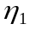 | WOM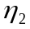 | PI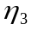 | B | WOM | PI | B | WOM | PI
P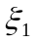 | 0.22 |  | 0.26 |  |  | 0.05 | 0.22 |  | 0.31
PC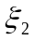 | 0.25 | 0.35 |  | 0.16 |  | 0.05 | 0.41 | 0.35 | 0.05
C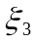 |  | 0.25 | (-0.21) | 0.12 |  | 0.003 | 0.12 | 0.25 | -0.18
B |  |  | 0.22 |  |  |  |  |  | 0.22
WOM | 0.47 |  | 0.012 |  |  | 0.10 | 0.47 |  | 0.11

TABLE 5-4
Significant determinant and model fit indices for model 1and 2
Paths / Estimation Method | Model 1_{ML} | Model 1_{GLS} | Model 2_{ML} | Model 2_{GLS}
γ11 (Price → Brand) | 0.2404** | 0.0983
γ13 (Price →Purchase intention) | 0.2688** | -0.0647
γ21 (Product Characteristics →Brand) | 0.2582** | 0.2132** | 0.3196** | 0.3181***
γ22 (Product Characteristics →Word-of-mouth Communication) | 0.3560** | 0.2341** | 0.3522** | 0.2803**
γ33 (Compatibility→ Purchase Intention | -0.2168* | -0.2168* | -0.2191 | -0.2736*
γ32 (Compatibility →Word-of-mouth Communication) | 0.2532*** | 0.1753* | 0.2520** | 0.1678*
β13 (Brand → Purchase Intention) | 0.2281* | 0.1825 | 0.3401*** | 0.2564***
β21 (Word-of-mouth Communication →Brand) | 0.4779*** | 0.4378*** | 0.4698*** | 0.4185***
β23 (Word-of-mouth Communication → Purchase Intention) | 0.012 | -0.0444 | -0.0264 | -0.0573
Model fit indices
GFI | 0.89 | 0.90 | 0.91 | 0.92
AGFI | 0.84 | 0.85 | 0.86 | 0.88
PGFI | 0.70 | 0.70 | 0.67 | 0.69
RMR | 0.10 | 0.16 | 0.08 | 0.13
RMSEA | 0.07 | 0.05 | 0.07 | 0.05
CFI | 0.86 | 0.70 | 0.90 | 0.79
NFI | 0.79 | 0.55 | 0.85 | 0.65
Note: A “*” symbol in path corresponds the level of significant. * denotes that the path is significant at p<0.05. “**” denotes that the path is significant at P<0.01. “***” denotes that path is significant at P<0.001. The boldface character serves as insignificant determinant.[ GFI, goodness of fit index; AGFI, adjusted goodness of fit index; parsimonious goodness of fit index, PGFI; room mean square residual, RMR; root mean squared error of approximation, RMSEA; comparative fit index, CFI; normed fit index, NFI.]
TABLE 5-5
Significant determinant and model fit indices for model 1and 2
Paths / Estimation Method | Model _{ML} | Model 3_{GLS} | Model 4_{ML} | Model 4_{GLS}
γ11 (Price → Purchase Intention) | -0.2730*** | -0.00459
γ21 (Product Characteristics →Purchase Intention) | 0.1950 | -0.0813 | 0.3264** | 0.2237*
γ31 (Compatibility → Purchase Intention) | -0.0176 | -0.00516 | -0.2258* | -0.2455*
γ41 (Brand →Purchase Intention) | 0.1646 | -0.00642 | 0.1924** | 0.1024
γ51 (Word-of-mouth Communication→ Purchase Intention) | -0.0284 | -0.0558 | -0.0428 | -0.0069
Model fit indices
GFI | 0.75 | 0.85 | 0.86 | 0.91
AGFI | 0.66 | 0.79 | 0.79 | 0.86
PGFI | 0.61 | 0.69 | 0.68 | 0.70
RMR | 0.17 | 0.23 | 0.15 | 0.20
RMSEA | 0.13 | 0.08 | 0.09 | 0.06
CFI | 0.56 | 0.42 | 0.82 | 0.73
NFI | 0.52 | 0.35 | 0.77 | 0.60
Note: A “*” symbol in path corresponds the level of significant. * denotes that the path is significant at p<0.05. “**” denotes that the path is significant at P<0.01. “***” denotes that path is significant at P<0.001. The boldface character serves as insignificant determinant.[ GFI, goodness of fit index; AGFI, adjusted goodness of fit index; parsimonious goodness of fit index, PGFI; room mean square residual, RMR; root mean squared error of approximation, RMSEA; comparative fit index, CFI; normed fit index, NFI.

FIGURE 5-2
The structural model results for model 1_{ML}
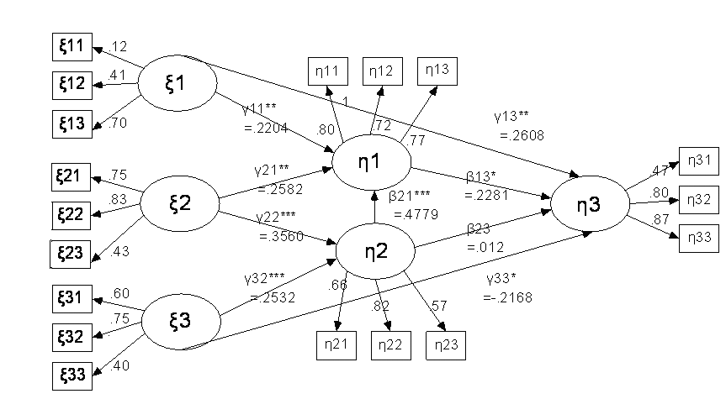
Note: The subscript “ML” and “GLS” serves as parametric estimation on each model structure.

FIGURE 5-3
The structural model results for model 1_{GLS} 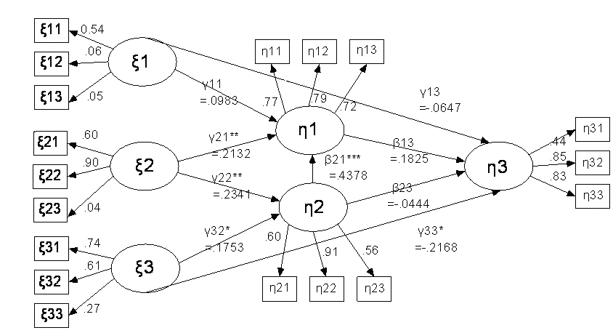

FIGURE 5-4
The structural model results for model 2_{ML}
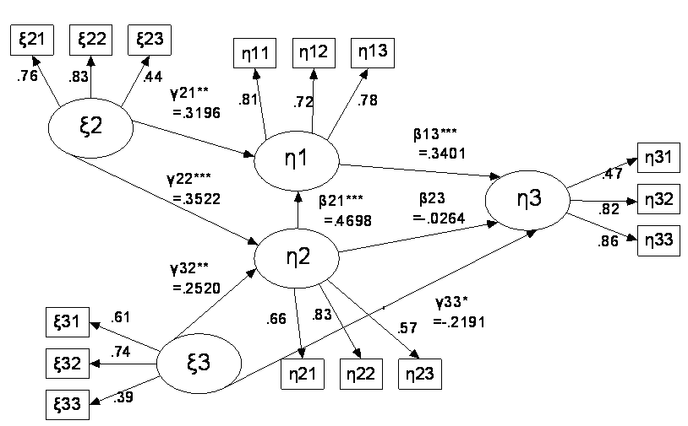
FIGURE 5-5
The structural model results for model 2_{GLS}
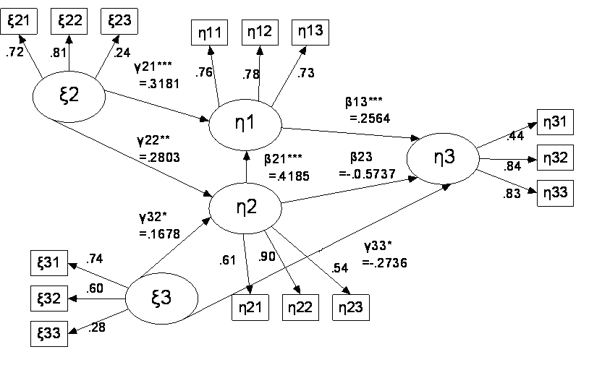
FIGURE 5-6: The structural model results for model 3_{ML} FIGURE 5-7: The structural model results for model 3_{GLS}
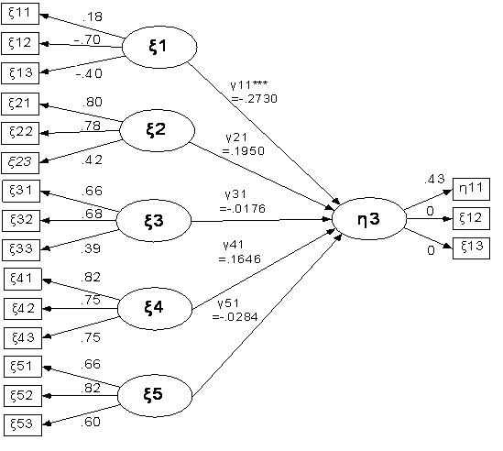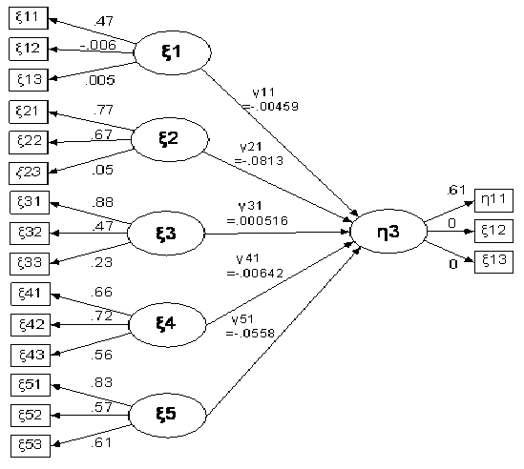
FIGURE 5-8: The structural model results for model 4_{ML} FIGURE 5-9: The structural model results for model 4_{GLS}
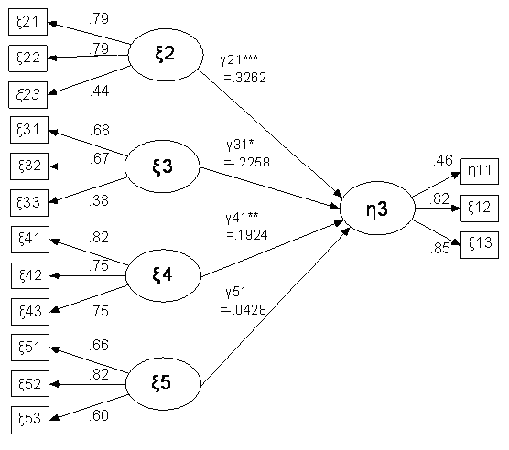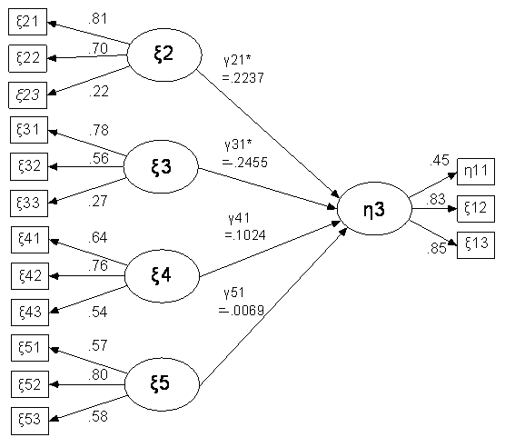
6. Conclusion
It demonstrates the model validation on the estimated models and reveals the causal relationships. Each estimated model leads to different performances accounted for maximum likelihood (ML) and generalized least-squared (GLS). The plausible model is validated and be confirmed the previous hypotheses. But it is a little different with initial hypotheses derived from interviews.
In validated procedures, the model 1_{GLS}, 2_{GLS}, 3, and 4 shows more poorly than model 1_{ML} and 2_{ML} in terms of reasonable model fit indices, significant determinant, and SMC. We finally employ the model 1_{ML} to be the conceptual mode because players argues that price always plays the crucial role for purchase intention of home video game console. That is why model 2_{ML} is not considered in this study.
The conceptual model is be validated that the product characteristic toward brand and word-of-mouth is significant determinant separately. The compatibility toward word-of-mouth communication and purchase intention (PI) is significant determinant separately. It deserves to be mentioned that a causal relationship between compatibility and PI is reversed. (i.e., the more compatibility we concerned on HVGC, the less PI we have.) It is reasonable to suspect that the compatibility companies focus on is not receivable for consumers such as the compatible with previous version of game. Most consumers show the regard of whether to refit the HVGC by themselves so that enable them to play another version of game even an illegal copy. It is the serious issue over the world. One of professional players explained that the company claimed HVGC is compatible with other devices; however, it could not bring the consumer satisfaction.
Nevertheless, the word-of-mouth communication has significant determinant on brand. The empirical study also supported with our findings that complaints will lead to brand switching through negative word-of-mouth (NWOM) communication (Richins 1983). Unfortunately, a significant relationship is not found between word-of-mouth communication and PI in overall model. We inferred that the format of word-of-mouth communication related to HVGC is not vivid; in other word, the PI of HVGC can’t be simulated by word-of-mouth communication among consumers. The empirical studies also had been confirmed that the vivid word-of-mouth communication is the critical factors on PI compared with printed information for product promotion (Herr Paul M., Kardes Frank R et al. 1991). More specifically, to draw out marketing strategies arousing the PI on HVGC through vivid word-of-mouth communication is primary concerned for companies; don’t just print information about HVGC’s functions.
To consider the role of price, significant determinant and positive relationship are found toward PI and brand respectively in model 1_{ML}. In the marketing strategy, reducing price for old HVGC is due to arouse purchase intention while the improved product launches. The marketing strategy is also consistent with results and the background survey, which indicates that price has been verified a significant impact on purchase intention (Rao and Monroe 1988) and more positive impact on when brand message is present (Monroe and Krishnan 1985).
Consequently, the brand is positively influenced by product characteristics. Unfavorable product characteristics lead to be compliant for a specific brand through word-of-mouth communication. Brand name is crippled if the company cared nothing at all about complaints for HVGC. Similarity, the result indicates the word-of-mouth is positively affected by product characteristics. In fact, the detail on product specification is hard to be discernible because of professional knowledge on HVGC. Hence, consumers usually depend on word-of-mouth communication among individual, who have a deep knowledge of product specification such as professional players or experts of video game console. This study indicates that marketing manager should give attention to product characteristics because it can influence the core asset of company: brand. This brings out issues that the brand name can be influenced by (un)favor product characteristics through word-of-mouth communication; that is to say, the brand switch results in an effect of word-of-mouth communication (Florian V Wangenheim and Tomas Bayon 2004).
In this study, the contribution of this study is identified purchase intention of home video game console that affected by five variables via directly and indirectly and validated different models. This study employed ML and GLS is to verify the difference of model performance. Hence, the strict experiment on each model suggests that model 1_{ML} is an appropriate construct in relation to model 2, 3 and 4.

Appendix

Responses to the items in all variables are measured on a 5-point Likert-tpye scale (ranging from 1=”strongly disagree” to 5=”strongly agree”
Strongly Disagree | Disagree | Neutral | Agree | Strongly  Agree

TABLE 666
The Items to Responses
Items
Price
P1 | I rather lean to buy the high price of HVGC.
P2 | I have expected acceptable rang of price in purchase HVGC.
P3 | The price of licensed software disk is important for me.
Product characteristics
PC1 | I am interested in clips of high-pixel.
PC2 | I am interested in clips of high-sound track.
PC3 | I am interested in well-designed controller.
Compatibility
C1 | I am considered whether to support the non-certified product.
C2 | I am considered the compatibility of peripheral products.
C3 | I am considered whether to be easy to control on controller or not.
Word-of-mouth Communication
WOM1 | I am concerned primarily that products have excellent word-of-mouth communication.
WOM2 | I think that the HVGC of good word-of-mouth held excellent quality.
WOM3 | I spent more time on searching information of HVGC of interest.
Brand
B1 | The good brand image is represented as good quality.
B2 | The good brand image can reduce the risk on HVGC.
B3 | The good brand image is equivalent to high reputation on HVGC.
Purchase Intention
PI1 | I am willing to buy HVGC within three months.
PI2 | I am willing to buy (or continue to use) on HVGC.
PI3
Note: The term “HVGC” serves as “home video game console”.

Reference

Anderson, J. C. and D. W. Gerbing (1984). "The Effect of Sampling Error on Convergence, Improper Solutions, and Goodness-of-fit Indices for Maximum Likelihood Confirmatory Factor Analysis." Psychometrika 49(2): 155-173.

Aoyama, Y. and H. Izushi (2003). "Hardware gimmick or cultural innovation? Technological, cultural, and social foundations of the Japanese video game industry." Research Policy 32(3): 423-444.

Ashesh Mukherjee and W. D. Hoyer (2001). "The Effect of Novel Attributes on Product Evaluation." Journal of Consumer Research 28(3): 462-472.

Astebro;, T. (2004). "Sunk Costs and the Depth and Probability of Technology Adoption." The Journal of Industrial Economics 52(3): 381-399.

Augusto de Matos, C., C. T. Ituassu, et al. (2007). "Consumer Attitudes toward Counterfeits: A Review and Extension." Journal of Consumer Marketing 24(1): 36-47.

Bayus, B. L. (1985). "Word of Mouth: The Indirect Effects of Marketing Efforts." Journal of Advertising Research 25(3): 31-39.

Bennett, P. D. and G. D. Harrell (1975). "The Role of Confidence in Understanding and Predicting Buyers' Attitudes and Purchase Intentions." Journal of Consumer Research 2(2): 110-117.

Bentler, P. M. (1990). "Comparative Fit Indexes in Structural Models." Psychological Bulletin 107(2): 238-246.

Bentler, P. M. and D. G. Bonett (1980). "Significance Tests and Goodness of Fit in the Analysis of Covariance Structures." Psychological Bulletin 88(3): 588-606.

Biel, A. L. (1992). "How Brand Image Drives Brand Equity." Journal of Advertising Research 32(6): 6-12.

Castaño, R., M. Sujan, et al. (2008). "Managing Consumer Uncertainty in the Adoption of New Products: Temporal Distance and Mental Simulation." Journal of Marketing Research 45(3): 320-336.

Cheolho Y. and Sanghoon K. (2007). "Convenience and TAM in a Ubiquitous Computing Environment: The Case of Wireless LAN." Electronic Commerce Research and Application 6(1): 102-112.

Chernatony, L. D. and G. McWilliam (1989). "Branding terminology the real debate." Marketing Intelligence & Planning 7(7/8): 29-32.

Chow;, S. W. (2007). Can Nintendo Get its Crown Back? Examining the Dynamics of the U.S. Video Game Console Market. Engineering and Management. Massachusetts, Massachusetts Institute of Technology. Master: 3-125.

Chu;, W., B. Choi;, et al. (2005). "The Role of On-line Retailer Brand and Infomediary Reputation in Increasing Consumer Purchase Intention." International Journal of Electronic Commerce 9(3): 115-127.

Cindy M. Y. Chung and P. R. Darke (2006). "The Consumer as Advocate: Self-relevance, Culture,and Word-of-Mouth." Marketing Letters 17(4): 269-279.

d' Astous, A. and S. A. Ahmend (1992). "Multi-Cue Evaluation of Made-In Concpet: A Conjoint Analysis Study in Belgium." Journal of Euromarketing 2(1): 9-22.

d’Astous, A. and S. A. Ahmed (1992). "Multi-cue Evaluation of Made-in Concept: A Conjoint Analysis Study in Belgium''." Journal of Euromarketing 2(1): 9-29.

Dee T. Allsop, Bryce R. Bassett, et al. (2007). "Word of Mouth Research: Principles and Applications." Journal of Advertising Research 47(4): 398-411.

Dhar, R. and S. J. Sherman (1996). "The Effect of Common and Unique Features in Consumer Choice." Journal of Consumer Research 23(3): 93-203.

Dhebar, A. (1995). "Complementarity, Compatibility, and Product Change: Breaking with the Past?" Journal of Product Innovation and Management 12(2): 136-152.

Dhebar, A. (1995). "Complementarity, Compatibility, and Proudct Change: Breaking with the past?" Journal of Product Innovation Management 12(2): 136-152.

Dillon;, T. W. and H. L. Reif; (2006). "Identifying Purchase Perceptions that Promote Frequent e-commerce Buying." International Journal of Electronic Marketing and Retailing 1(1): 48-66.

Dodds, W. B. (1991). "In Search of Value: How Price and Store Name Information Influence Buyers Product Perceptions." The Journal of Services Marketing 5(3): 27-36.

Dodds, W. B., K. B. Monroe, et al. (1991). "Effects of Price, Brand, and Store Information on Buyers' Product Evaluations." Journal of Marketing Research 28(3): 307-319.

Donnelly, J. H. (1973). "Degrees of Product Newness and Early Trial." Journal of Marketing Research 10(3): 295-300.

Elrod Erry and Russell S. Winer (1982). "An Empirical Evaluation of Aggregation Approaches for Developing Market Segments." Journal of Marketing 46(4): 65-74.

Florian V Wangenheim and Tomas Bayon (2004). "The Effect of Word of Mouth on Services Switching: Measurement and Moderating Variables." European Journal of Marketing 38(9/10): 1173-1185.

Fornell;, C. and D. F. Larcker; (1981). "Structural Equation Models with Unobservable Variables and Measurement Error: Algebra and Statistics." Journal of Marketing Research 18(3): 382-388.

Gardner, B. B. and S. J. Levy; (1955). "The Product and the Brand." Harvard Business Review 33(2): 33-39.

Gilbert;, N., W. Jager;, et al. (2007). "Complexities in Markets: Introduction to the Special Issue." Journal of Business Research 60(8): 813-815.

Gray M. Erickson and J. K. Johansson (1985). "The Role of Price in Multi-Attribute Product Evaluations." Journal of Consumer Research 12(2): 195-200.

Grewal, D., R.; , J. B. Krishnan, et al. (1998). "The Effect of Store Name, Brand Name and Price Discounts on Consumers' Evaluations and Purchase Intentions." Journal of Retailing 74(3): 331-352.

Guadani Peter M. and Little John D.C. (1983). "A Logit Model of Brand Choice Calibrated on Scanner Data." Management Science 2(3): 203-238.

Hair, J. F., R. E. Anderson, et al. (1998). Multivariate Data Analysis. New York, Prentice-Hall.

Hans H. B. and Stuart J. B. (2005). "Driving Consumer Acceptance of Mobile marketing: A Theoretical Framework and Empirical Study." Journal of Electronic Commerce Resarch 6(3): 181-192.

Herr Paul M., Kardes Frank R, et al. (1991). "Effects of Word-of-Mouth and Product-Attribute Information on Persuasion: An Accessibility-Diagnosticity Perspective." Journal of Consumer Research 17(4): 454-461.

Howard, J. A. (1989). Consumer Behavior in Marketing Strategy. Englewood Cliffs, NJ, Prentice Hall.

Howard, J. A. and J. N. Sheth (1969). The Theory of Buyer Behavior. New York, Wiley.

J.C.;, A. and G. D.W.; (1988). "Structural Equation Modeling in Practice: a Review and Recommended two-step approach." Psychological Bulletin 103(3): 459-489.

Jacqueline J.Brown and P. H. Reingen (1987). "Social Ties and WOM Referral Behavior." Journal of Consumer Research 14(3): 350-362.

Joreskog, K. G. and D. Sorbom (1981). Analysis of Linear Structural Relationships by the Method of Maximum Likelihood. Chicago, National Educational Resources, Inc.

Joreskog, K. G. and D. Sorbom (1982). "Recent Developments in Structural Equation Modeling." Journal of Marketing Research 19(4): 404-416.

Joreskog, K. G. and D. Sorbom (1996). Lisrel 8: User's Reference Guide. Chicago, International Scientific Software

Kardes, F. R., G. Kalyanaram, et al. (1993). "Brand Retrieval, Consideration Set Composition, Consumer Choice, and the Pioneering Advantage." Journal of Consumer Research 20(1): 62-75.

Kim;, S. (2008). "Appropriation of Wireless Technology: Direct Impacting Factors on the Youth's Adoption Intention and Usage of the Wireless Application Protocol Phone." Information Technology Journal 7(8): 1116-1124.

Labay, D. G. and T. C. Kinnear (1981). "Exploring the Consumer Decision Process in the Adoption of Solar Energy Systems." Journal of Consumer Research 8(3): 271-278.

Labay, D. G. and T. C. Kinnear (1981). "Exploring the Consumer Decision Process in the Adoption of Solar Energy Systems." Journal of Consumer Research 8(3): 1-12.

Lancaster, K. J. (1966). "A New Approach to Consumer Theory." Journal of Political Economy 74(2): 132-157.

Lefkoff-Hagius, R. and C. H. Mason (1993). "Characteristic, Beneficial, and Image Attributes in Consumer Judgments of Similarity and Preference." Journal of Consumer Research 20(1): 100.

Lundeen, H. K. and L. C. Harmon (1995). "Service Recovery in Commercial Real Estate Management." Journal of Property Management 60(3): 30-32.

Lyman E. Ostlund (1974). "Perceived Innovation Attributes as Predictors of Innovativeness." Journal of Consumer Research 1(2): 23-29.

Maheswaran, D. and J. Meyers-Levy (1990). "The Influence of Message Framing and Issue Involvement." Journal of Marketing Research 27(3): 361-367.

Mantel, S. P. and F. R. Kardes (1999). "The Role of Direction of Comparison, Attribute-Based Processing, and Attitude-Based Processing in Consumer Preference." Journal of Consumer Research 25: 4.

Margherita, P. (2007). "A Vicarious Innovativeness Scale for 3G Mobile Services: Integrating the Domain Specific Innovativeness Scale with Psychological and Ratinal Indicators." Technology Analysis & Strategic Management 19(6): 709-728.

Meyerowitz BE and C. S.; (1987). "The Effect of Message Framing on Breast Self-Examination Attitudes, Intentions, and Behavior." Journal of Personality and Social Psychology 52(3): 500-510.

Michael S. G. and John T. M. (1999). "Logistics Research Methods: Employing Structural Equation Modeling to Test for Construct Validity." Journal of Business Logistics 20(1): 33-57.

Mitra, A. (1995). "Price Cue Utilization in Product evaluations: The Moderating Role of Motivation and Attribute Information." Journal of Business Research 33(3): 187-195.

Monroe, K. B. and R. Krishnan (1985). "The effect of price on subjective product evaluations." Perceived Quality, Lexington Books, Lexington, MA: 209-32.

Moorthy, S., B. T. Ratchford, et al. (1997). "Consumer Information Search Revisited: Theory and Empirical Analysis." Journal of Consumer Research 23(4): 263-277.

Morris, R. T. and Claire S.B. (1970). "The Chaos of Competition Indicated by Consumer Reports." Journal of Consumer Affairs 4(2): 103-112.

Mulaik, S. A., L. R. James, et al. (1989). "Evaluation of Goodness-of-fit Indices for Structural Equaation Models." Psychological Bulletin 105: 430-445.

Nandan;, S. (2005). "An Exploration of the Brand Identity-Brand Image Linkage: A Communications Perspective." Journal of Brand Management 12(4): 264-278.

Newman, J. W. (1957). "New Insight, New Progress for Marketing." Harvard Business Review 35(6): 95-102.

O'Guinn, T. C. and L. J. Shrum (1997). "he Role of Television in the Construction of Consumer Reality." Journal of Consumer Research 23(4): 278-294.

Pagani;, M. (2007). "A Vicarious Innovativeness Scale for 3G Mobile Services: Integrating the Domain Specific Innovativeness Scale with Psychological and Rational Indicators." Technology Analysis & Strategic Management 19(6): 709-728.

Patricia A. Goering (1985). "Effects of Product Trial on Consumer Expectations, Demand, and Prices." Journal of Consumer Research 12(1): 74-82.

Peter C.R. (1979). "Price-Quality Coorelation for Packaged Food Products." Journal of Consumer Affairs 13(2): 236-247.

Peter;, C. (1969). The Begrudging Index and the Subjective Value of Money, In Pricing Strategy. London, Staples Press, Ltd.

Philip Gendall, Janet Hoek, et al. (2006). "Message Framing Effects on Price Discounting." Journal of Product & Brand Management 15(7): 458-465.

Prieger;, J. E. and W.-M. Hu; (2006). An Empirical Analysis of Indirect Network Effects in the Home Video Game Market. California, The Network, Electronic Commerce, and Telecommunications Institution: 1-44.

Rao, A. R. and K. B. Monroe (1988). "The Moderating Effect of Prior Knowledge on Cue Utilization in Product Evaluations." Journal of Consumer Research 15(2): 253.

Rao, A. R. and W. A. Sieben (1992). "The Effect of Prior Knowledge on Price Acceptability and the Type of Information Examined." Journal of Consumer Research 19(2): 256-270.

Reynolds, K. E. and M. J. Arnold (2000). "Customer Loyalty to the Salesperson and the Store: Examining Relationship Customers in an Upscale Retail Context." The Journal of Personal Selling & Sales Manangement 20(2): 89-98.

Richins, M. L. (1983). "Negative Word-of-Mouth by Dissatisfied Consumers: A Pilot Study." Journal of Marketing 47(1): 68-78.

Robert East, Kathy Hammond, et al. (2007). "The Relative Incidence of Positive and Negative Word of Mouth: A Multi_Category Study." International Journal of Research in Marketing 24(2): 175-184.

Rosemary R. Seva, Henry Been-Lirn Duh, et al. (2007). "The Marketing Implications of Affective Product Design." Applied Ergonomics 38: 723-731.

Ruby Turner Morris and C. S. Bronson (1969). "The Chaos of Competition Indicated by Consumer Reports." Journal of Marketing 33(3): 26-34.

Rust, R. T., C. Lee, et al. (1995). "Comparing Covariance Structure Models: A General Methodology." International Journal of Research in Marketing 12(4): 279-291.

Sirgy, M. J. (1982). "Self-Concept in Consumer BehaviorRL: A Critical Review." Journal of Consumer Research 9(3): 287-300.

Sproles, G. B. (1977). "New Evidence on Price and Product Quality." Journal of Consumer Affairs 11(1): 63-77.

Steiger, J. H. (1990). "Structural Model Evaluation and Modification: An Interval Estimation Approach." Multivariate Behavioral Research 25(2): 173-180.

Susan L. Holak (1988). "Determinants of Innovative Durables Adoption: An Empirical Study with Implications for Early Product Screeing." Journal Product of Innovation Management 5(1): 50-69.

Susan L. Holak and D. R. Lehmann (1990). "Purhase Intention and the Dimensions of Innovation: An Exploratory Model." Journal Product of Innovation Management 7(1): 59-73.

Tanaka, J. S. and G. J. Huba (1984). "Confirmatory Hierarchical Factor Analyses of Psychological Distress Measures." Journal of Personality and Social Psychology 46(3): 621-635.

Thakor, M. V., ; and L. P. Katsanis (1997). "A Model of Brand and Country Effects on Quality Dimensions: Issues and Implications." Journal of International Consumer Marketing 9(3): 79-100.

Urbany, J. E., P. R. Dickson, et al. (1989). "Buyer Uncertainty and Information Search." Journal of Consumer Research 16(2): 208-215.

Wyer, R. S. and T. K. Srull; (1989). "Person Memory and Judgment." Psychological Review 96(1): 58-83.

Zeithaml;, V. A., L. L. Berry;, et al. (1993). "The Nature and Determinants of Customer Expectations of Services." Journal Academy Marketin Science 21(1): 1-12.

