計算機概論 C語言

Dev-C++ 簡介
這是一套免費並且開放原始碼的 C++ 程式設計軟體，附上 GNU GCC 編譯器，體積小功能強大 。它包括多頁面視窗、工程編輯器，在工程編輯器中集合了編輯器、編譯器、連接程式和執行程式。 也提供高亮度語法顯示的，以減少編輯錯誤。
Step.1 下載Dev C軟體 http://www.bloodshed.net/devcpp.html
Step.2 完成安裝
Step.3 開啟軟體
Step.4 檔案開新檔案原始碼 進入編輯頁面
Step.5 完成程式碼撰寫後，點選F9編譯執行

範例Example-1 : Hello world (將Hello world這行字串顯示到螢幕上)

#include<stdio.h>
#include<stdlib.h>

int main(void){
printf("Hello world!\n");

system("PAUSE");
return 0;
}
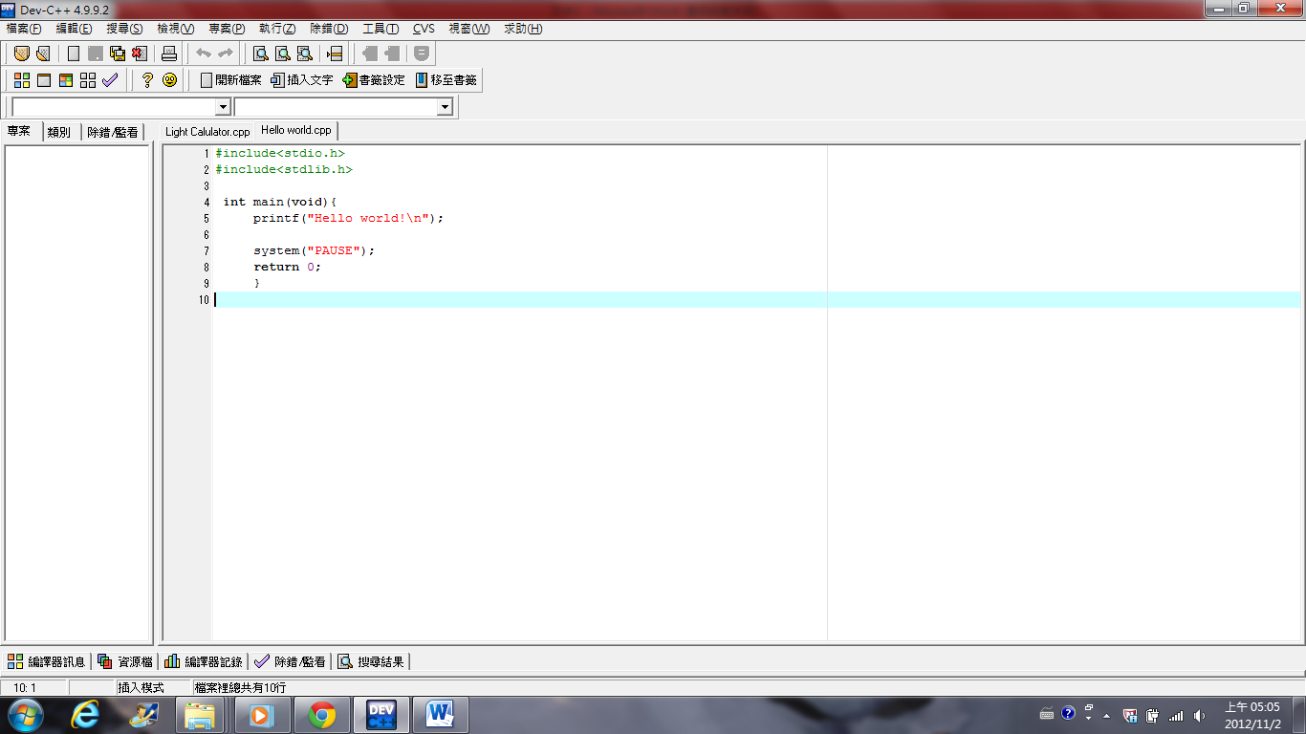
執行結果：
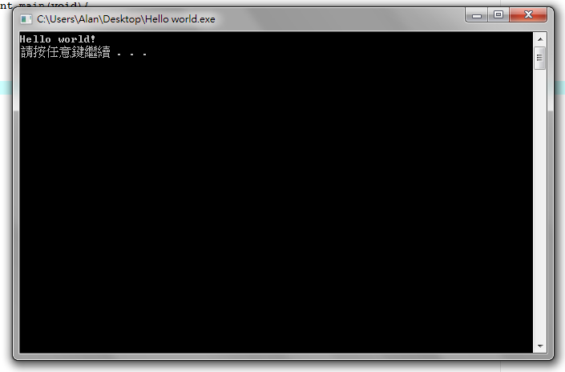

範例Example-2 : 計算機 (簡易計算機)

#include<stdio.h>
#include<stdlib.h>
int main(void){
printf("It's a calculator with the function of four fundamental operations of arithmetic.\n\n");
float op1,op2,ans; //make a define of two [op]operation and the answer variable.
char tor='a'; //make a define of a opera[tor].
int r=1,c=0; //[r]euse the calculator and always turn on.
//[c]ondition: to confirm if the operator is the proper kind
while(r!=0){
printf("Type your first number : ");
scanf("%f",&op1); //get the first operation by "scanf".
fflush(stdin); //flush the data in buffer to having the next "scanf"

while(c==0){
printf("\n Type your operator : ");
scanf("%c",&tor);
fflush(stdin);
if(tor!='+'&&tor!='-'&&tor!='*'&&tor!='/')
{ //make sure the operator is true or not.
c=0; //set condition into close than we should set the operator again.
printf("\n Please just type the operators such as \" + , - , * , / \" ");
}
else //the operator is fit set the condition onto "on"
c=1;
}

printf("\nType your last number : ");
scanf("%f",&op2);
fflush(stdin);

if(tor=='+') //Read the char variable and find out the corresponding operator.
ans=op1+op2;
if(tor=='-')
ans=op1-op2;
if(tor=='*')
ans=op1*op2;
if(tor=='/')
ans=op1/op2;
printf("\nThe answer = %f \n\n\n\n",ans); //Show off the result.
c=0; //set the condition back.
}
system("PAUSE");
return 0;
}

執行結果：

Step.1輸入第一個運算數值
Step.2輸入想使用的運算元(+ or - or * or / )
Step.3輸入第二個運算數值
得到結果
使用Ctrl+c離開執行檔

