E-Commerce Website Development
Website Analysis Project

God Game
(神來也Shen Lai Ye)

Advisor : John Sum
Student : Vincent Su ,Vincent Wang, Dean Lin

Outline
- Introduction
Company Introduction P2
Company Structure P3
Provided services P3
Business model P4
Earning form ads P5
Cost Estimation P5
Competitors P8

- Payment
Credit services P10
Credit service area P10
Financial partnerships P11
Charging mechanism P11
Account partners P12

- Website structure
Website programming language P14
Website Information P14
Website structure P14
Sequence Diagram P15
Process of refund P16

- Website Infrastructure
Domain Information P17
Recordform Whois P17
Site Profile and Search Rank P17
Server Stats P18
Site Map P18
Technique of connection P19
HTTP Header Analysis P20
Audience Demographics P21

- Introduction
Company Introduction- God Games
The company we chose is the God Games which is the most popular online mahjong and poker web-game provider in Taiwan. Godgame first combined their web games with Facebook then rapidly gain publicity and reputation, soon it became the most popular web-game. The services provided by God Games not only include playing mahjong or poker, it has credit services which you can buy game credits to have more access to the game. Below is a chart which contains the basic information of God Games.

Company Name | 慧邦科技股份有限公司
Website | God Game(神來也Shen Lai Ye )
Domain | http://www.godgame.com.tw/
Company | Godgame Incorporation
Service category | Multiplayer flash game , Mobile game developing and operating
President of Company | Jiang Yong Xiang江永祥
Background | Worked at Acer in AcerGameZONE in 1997 as an assistant manager. Founded Godgame Inc. at 2005
Number of Employees | around 100
Company Capital | 66 Million (Info from Ministry of Economic Affairs ,2012)
Company Brief | Established in 2005,Godgame Inc. started out in creating a social website called “Miniworld” then in 2008 developed “Godgame Mahjong” and “Big 2” . It is the first web game in Taiwan that combined login services with Facebook, Yahoo, Windows live and Google. Soon they reached 15 million members across Taiwan, Hong Kong, Singapore, Malaysia and America becoming the top Chinese chess and web gaming website.

Company Structure
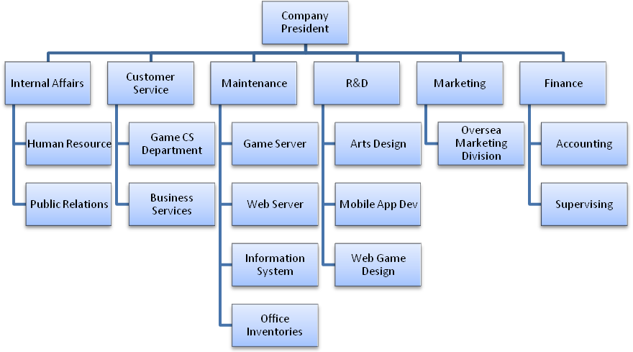

Since Godgame is not a listed company, lots of company data are not visible to the public, the company structure is estimated based on the same kinds of firms such as Gamania and Softworld, through looking at their financial reports and annual reports, we’ve come up with a similar organization chart which included all the necessary departments that is needed to run and online game business. Generally speaking , the most important part of and online gaming provider are the R&D and maintenance department to keep the services running and working, especially when it comes to web-based games, art design are extremely important. Other department’s info is retrieved from the Godgame website such as customer service and human resources are guesses from online information.

Provided services
- Membership services: Login, Account control.
Services for recording user’s personal data, game score data, credits and soon.
- Game services: Web-based games, Mobile-based Games.
Game services have 2 types – Web base games and mobile base games.
- Game credit service: Credit Purchase, Credit usage.
Credits are for buying virtual items. Items are some tools to have advantage ingame or some decoration for virtual avatar.
- Customer service system: problem complaint, FAQ, contact the company.
A service to solve user’s problem.
Web Games | Shen Lai Ye16 Mahjong  Shen Lai Ye13 Mahjong  Shen Lai Ye Japanese Mahjong  Shen Lai Ye Texas hold 'em  Shen Lai Ye Texas hold 'em 4 player version  Shen Lai Ye Big Two  Shen Lai Ye Thirteen  Shen Lai Ye Sevens  Shen Lai Ye Big Two (Hong Kong version)  Shen Lai Ye 99  Shen Lai Ye Big Fight  Shen Lai Ye Friend Village  Shen Lai Ye Mo Mo Taro Adventure
Games on Portable Devices | Shen Lai Ye Mahjong  Shen Lai Ye Texas hold 'em  Shen Lai Ye Big Two  Shen Lai Ye Sevens  Shen Lai Ye Thirteen  Shen Lai Ye13 Mahjong  Shen Lai Ye Big Two (Hong Kong version)  Shen Lai Ye Dark Chess

Business model
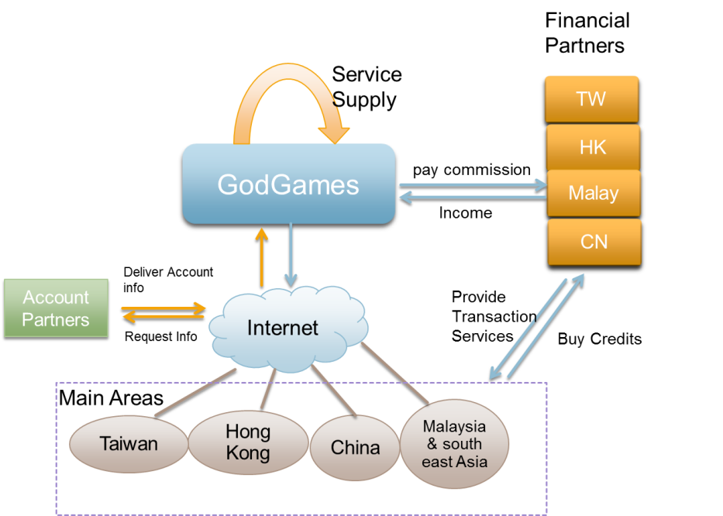
The Business model consists of the financial partners, account partners and the area of customers. From the starting point Godgame provides its own services of the web-games, all the R&D design and maintenance are done by themselves, leaving an arrow pointing to themselves. Then the website services are deployed through the internet. Users can login their account through the account partners data or the account that’s in Godgame, then they can do transaction through the channels of the different financial suppliers. Once transaction is done, Godgame will pay commission to the financial partners which on the other hand profits are then given to Godgame.

Earning form ads
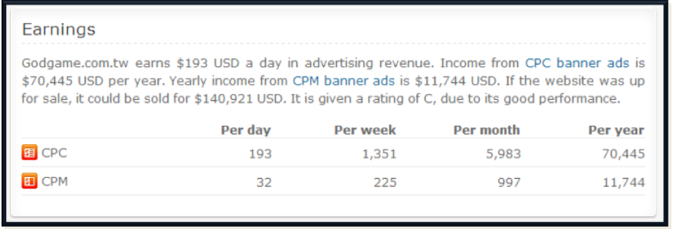
This statistic is generate by online analysis tool. It calculate a website’s earning from ads by website’s traffic. Nowadays, website owner will cooperate with some online ads companies. They put some banner ads and text ads to make profit. This might be God game’s minor income.
CPC: Cost per click.
CPM: Cost per mille. It is used to calculate the cost of advertising in a given medium.

Cost Estimation
In this part we will estimate roughly about the expenditure from staff salary and office rental. From the staff estimation, we analyzed the employment structure from 104.com.tw,the human resource website to gather information about the staff recruit. It will give us a brief picture of what employee does this company needs and the salary will give us information about the average per staff expenditure. The structure of the employees are also estimated based on the organization chart in the first section, with each department having their directors and managers and the attributes of an online gaming company , we’ve first come up with an estimation of the staff numbers in each department as its illustrated below.

Employees in total: around 100
  - Customer service: 15
  - Maintenance: 15
    - Game server: 5
    - Web server: 5
    - Information System: 5
  - R&D : 25
    - Art Design: 10
    - Mobile App: 5
    - Web Game: 10
  - Marketing: 15
  - Finance: 15
  - Internal Affairs: 15

Next we estimated the staff positions such as director, managers and other senior or junior crew member then gave each position a rough guess of salary as the chart below.

Internal affairs | num | $(k) | Total(k)
Chief executive of IA | 1 | 120 | 120
Chief of HR | 1 | 70 | 70
S_HR staff | 3 | 55 | 165
N_HR staff | 4 | 35 | 140
PR manager | 1 | 80 | 80
PR assistant manager | 1 | 70 | 70
PR staff | 5 | 50 | 250
Customer Service
CS manager | 1 | 80 | 80
Chief of Game CS Dep. | 1 | 65 | 65
Game CS staff | 10 | 40 | 400
Chief of Business services | 1 | 65 | 65
Business CS staff | 4 | 40 | 160
Maintenance
MT manager | 1 | 80 | 80
S_staff | 2 | 55 | 110
N_staff | 2 | 40 | 80
Office Inventory staff | 2 | 45 | 90

R&D | num | $(k) | Total(k)
RD Manager | 1 | 120 | 120
RD assistant manager | 1 | 100 | 100
Chief of Art | 1 | 90 | 90
Chief of mobile | 1 | 80 | 80
Chief of web | 1 | 80 | 80
S_Art staff | 4 | 60 | 240
N_Art staff | 3 | 45 | 135
S_Mobile staff | 3 | 60 | 180
N_Mobile staff | 4 | 45 | 180
S_Web staff | 4 | 65 | 260
N_Web staff | 3 | 45 | 135
Marketing
Chief Executive of Marketing | 1 | 120 | 120
Assistant manager | 1 | 100 | 100
Oversea manager | 1 | 85 | 85
S_Oversea staff | 4 | 60 | 240
N_Oversea staff | 2 | 45 | 90
S_staff | 4 | 60 | 240
N_staff | 2 | 45 | 90
Finance
Chief Executive of Finance | 1 | 120 | 120
Assistant manager finance | 1 | 100 | 100
Chief of accounting | 1 | 90 | 90
S_account staff | 6 | 70 | 420
N_account staff | 2 | 60 | 120
Chief of supervising | 1 | 70 | 70
Supervising staff | 2 | 65 | 130
Total | 95 |  | 5640

From the estimations above we can now know how much salary is paid each month to each department

Department | Employee Expenditure Per month
Internal affairs | 895
Customer Service | 770
Maintenance | 360
R&D | 1600
Marketing | 965
Finance | 1050
Total | 5640

Server & Power Consumption Information
The average Godgame.com.tw visitor visits about 6.76 pages before leaving again, this means that their servers handle about 881,896 page views per day and in term a total of 10 page views per second.
We estimate that this website uses 5 server(s), and with the average internet server using about 2,400 kWh of electricity per year, Godgame.com.tw will use more or less 12,000 kWh of power in that time span. Looking at the average cost of 0,17c per kWh, this website uses an estimated total of $2,040 USD on electricity per year.

Office Rental
From the real estate agency we managed to find a place near where the office of Godgame is located, and the size is able to fit 100 employee which is 91坪, the monthly rent is 110,000 .

Total Estimation
Compared to the employee expenses, the server power and office rental seems not that significant. Adding the total expense per month is about 5,800,000 which is not included office power consumption and water bill or office supplies. Most of the expenditures come from employee salary.

Competitors
Here is the top 5 member of online mahjong game, and also their sing, found year, traffic rank.
Competitors | Sign | Found | Traffic Rank in TW  (source: Alexa)
God game |  | 2005 | 152
GameTower |  | 2004.04 | 197
Betcity |  | 2000.05 | 827
FunTown |  | 2002 | 1267
iGame |  | 2000.02 | 28631
Until 2012/11/27

- Payment
Credit services
Credit services are the service that Godgamecompanies earn profit from, it provides customers to buy game credit with a number of methods such as online payment, telephone payment or credit card payment to buy the game credits. The credit service is provided in different countries, Taiwan, Hong Kong, Malaysia, Singapore and China. Each region has its own different way to purchase the credit from Godgame.

Taiwan
In Taiwan you can buy the credits through credit cards, web ATM, phone bills, internet bills, Mycard, GASH and some bank’s credit exchange policy. It offers the most methods to purchase.
Hong Kong
In Hong Kong, the purchasing methods are a lot less then Taiwan. Serving as the second largest region of customers, it only offers GASH credit deposit and exchange which you can turn your GASH credit from other games into the Godgame credit. Also there is the Babi credit transfer which is a kind of credit related to GASH.
Malaysia & Singapore
The Malaysia and Singapore region uses a kind of credit called RunsCard to pay the fees. The RunsCard is a third party credit that is used widely in those areas, which it provide various deposit categories and also can use it to pay Godgame. Also the Mycard are usable.
China
In mainland China , the services provide to the transaction are only using Alipay to buy credits. Alipay is a third party credit from the company Alibaba(阿里巴巴) in which many companies uses the transaction services it provides in China.

Credit service area
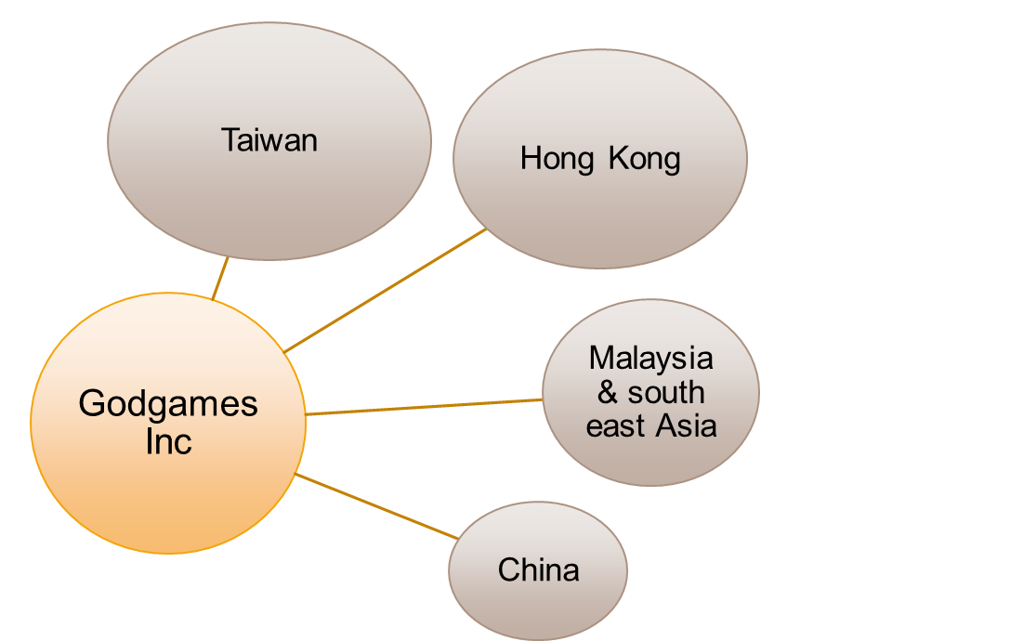
This chart illustrates the regions that the Godgame provide to, Taiwan with the biggest circle meaning the largest proportion of customers and Hong Kong placing second with Malay and China the smallest. According to demographic from online traffic survey website called Alexsa.com , the main users are from Taiwan which contains about 90 percent and China and Hong Kong have low statistics not to mention Malaysia and Singapore region.

Financial partnerships
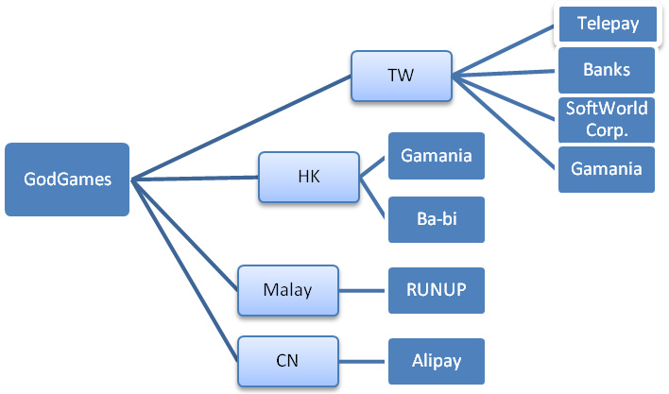
The financial partnerships are the companies that cooperate with Godgame in terms of the financial transaction services. As the above mentioned about different service areas, they each have different companies supporting the financial service in which we divided them into four regions with each has its provider. As you can see, Taiwan has the most company cooperating with Godgame since it has the widest variety to deliver transaction service. We call these chart financial partnerships other than service provider because from the different websites of the different companies they include a webpage naming business partners and both the God Game and they are put in. The ones supporting financial services in Taiwan come across telecoms, banks and industrial leaders, this gives the company an advantage or strength in the transaction process making it convenient to consumers if they want to purchase.

Charging mechanism
The charging mechanism is the different ways for a customer to do the transaction. In the Godgame transaction services, they use three kinds of payment channels. In this part we will explain how what the services are and how they work.
Telepay
Telepay is a company that intergrades all the payments that goes through local telecoms with residential or mobile phone number , which they negotiate with the telecoms and the companies that need payment through phone bills and serve as an intermediate firm that collects 20% commission from each transaction made by the company in this case Godgame have to give 20% for each transaction to Telepay.
Web ATM
The service provider of web ATM is E-SUN bank (玉山銀行) which they provide their Web transaction system to support the credit purchasing. Customers can pay by using the credit card online without having to go anywhere. E-sun bank charge a fixed amount of service charge per month and per transaction to Godgame.
Third party credit
Another kind of transaction is the third party credit. Godgame combine their credit services with other company’s credits to make the process of depositing credits more convenient for the customers. Credits such as Gash+, Mycard, Alipay, Runs card are used in the services, customers can either deposit by serial number or through buying any kind of these credits.

Account partners
Godgame either cooperate with other website or use some website’s API to integrate account. User can easily integrate account and don’t have to register a new one. The following picture shows the way to register account on god game.
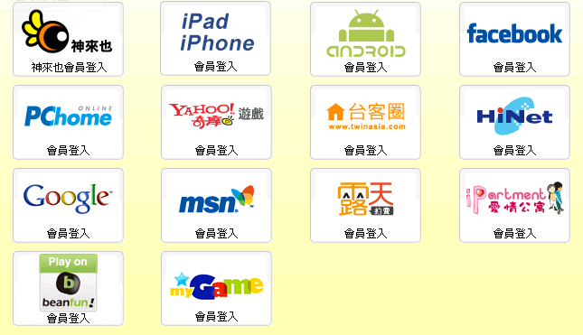
Account authentication technique
- JavaScript: Google, Windows Live, Facebook, Yahoo
- Portable devices client: Java (Android), Objective-C (iOS)
- Partner:PChome, Hinet, iPartment, Ruten(露天), MyGame, Beanfun, Twinasia(台客圈)
- Server side handle user data: PHP
Google, Windows Live, Facebook and Yahoo provide javascript API to use account authentication. On the portable devices, God game create native client program to communicate with server and stroe user data. All name under the “Partner” tag are companies that cooperate with God game. User can log in through these website’s account and partner company’s server will send data to God game’s server to create account.
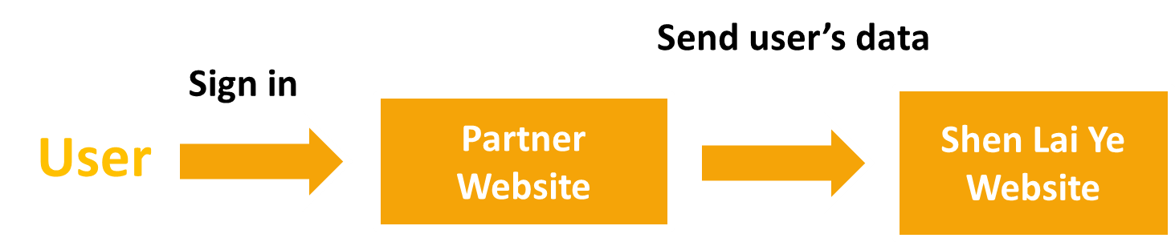

- Website structure
Website programming language
- Webpage: HTML, CSS, JavaScript, Flash, PHP
- Game:
  - Web client: Flash (for GUI),PHP
  - Portable devices client: Java(android) / Objective-C(iOS)
  - Server: PHP, Perl, MySQL
The website is creating by using HTML, PHP and JavaScript. Use CSS to adjust the object on the web page. Use php to communicate with MySQL database.
God game use Flash to create game. The game program use HTTP to communicate with server. This will prove later in the report.
One the mobile, they create game by using mobile system’s native language.

Website Information
- Favicon:
- Load Time: 1.489202 Seconds
- Daily Visitors: 16,062
- Daily Pageviews: 144,555
- Seo Score: 63.5%
- Daily Revenue: $ 967 USD
- Website Worth: $ 1,821,372 USD
Source: http://www.statmyweb.com/

Website structure
Website use a page that has every game’s links. Users choose the game they want to play and server will redirect user to the game’s page. The picture below shows the website structure.
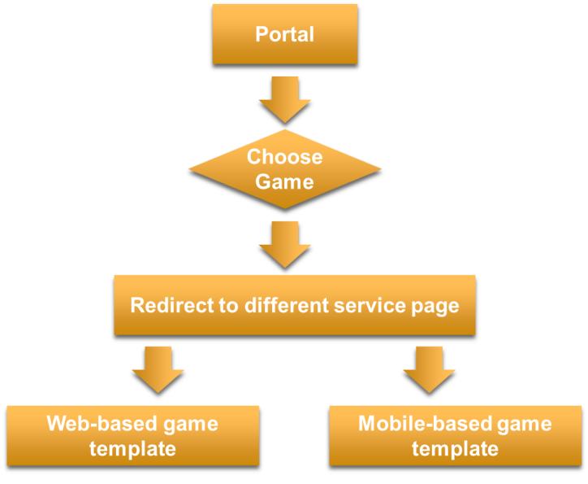
Sequence Diagram

The sequence diagram shows the process of registration, buy credits, use credits to but virtual items and play game. First, user regist an account on the website. Server use php program to store data into database. When buying credits, user will be redirect to the partner’s website. Once it done, partner’s server will send result back to God game’s server and will add credits into user’s account. When user use credits to buy virtual item, God game’s server will check user’s credits first, then deduct credits and add virtual items into user’s account. When playing game, user should wait server gather enough player to start. User’s every decision will send to game server to calculate result. After solving every player’s decision, the game server will send the result back to the user.
Account Data
Last Round of Game
Process result
Record in database
Send to other player
Result
Decision
......
Process result
Send to other player
Result
Decision
Game info
Play game
Wait other player
Initiate game
Generate game
Results
Deduct credits

Add virtual items
Buying virtual items
User information and
Select products
Deduct from
telephone bill
Add credits
Credits information
Results
Buy credits
Redirect to Partner’s
Website
Some
Buying information
Registration
Success!
Account Profile
Partner CHT
Server

Process of refund
If customer has problem of credits or want to refund, customer should go to the repot center on the website and send a support ticket. God game will solve your problem after know your condition.
Data you need to fill:
- Email
- Type of your problem
- What problem you encounter
- Some detail of your problem
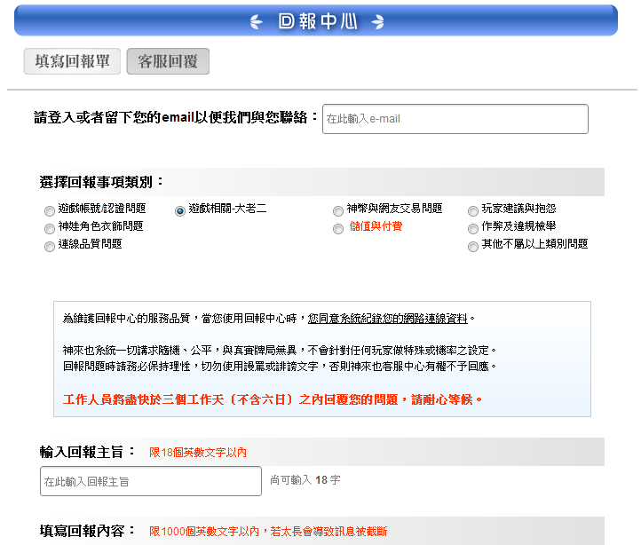
God game willreponse in 3 working day.

- Website Infrastructure
Domain Information
Domain Name: godgame.com.tw
Registrant: 慧邦科技股份有限公司(MiniWorld Inc.)
Address: 9F, No.19, Sec. 1, Hangzhou S. Rd., Zhongzheng Dist., Taipei
Contact:
- DNS Admin: dnsadmin@miniworld.com.tw
- TEL: (02)6632-9888
- FAX: (02)6630-8299
Record created on 2008-06-16 (YYYY-MM-DD)
Record expires on 2013-06-16 (YYYY-MM-DD)

"慧邦科技股份有限公司" owns about 15 other domains.
"dnsadmin@miniworld.com.tw"is associated with about 16 domains.
Whois History: 616 records have been archived since 2008-11-22.
Reverse IP: 1 other site is hosted on this server.

Domain servers in listed order:
ns129.godgame.com.tw：210.242.246.129
ns101.godgame.com.tw：60.199.198.101
ns251.godgame.com.tw：210.244.25.1
Registration Service Provider: SEEDNET

Whois Record
"慧邦科技股份有限公司" owns about 15 other domains.
Email Search: “dnsadmin@miniworld.com.tw” is associated with about 16 domains.
There are 616 records have been archived since 2008-11-22.
Reverse IP: 1 other site is hosted on this server.

Site Profile and Search Rank
Website Title: "神來也遊戲網: 免下載麻將、撲克類遊戲第一品牌!”
Description Relevancy: 6% relevant.
Quantcast Rank: #624,713
SEO Score: 81%
Terms: 82 (Unique: 67, Linked: 37)
Images: 4 (Alt tags missing: 3)
Links: 27 (Internal: 27, Outbound: 0)

Server Stats
IP Address:210.242.246.200
ASN: AS3462
IP Location:Taiwan- Taipei- Chunghwa Telecom Co. Ltd.
Response Code:200
Domain Status: Registered And Active Website

Site Map
Each of the marked web address is corresponds to the website.And the black mark site called ‘Compete’ site is the special activity website for each game.
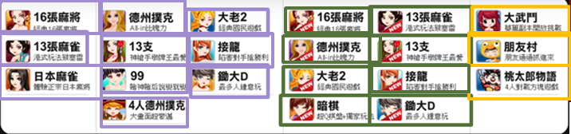
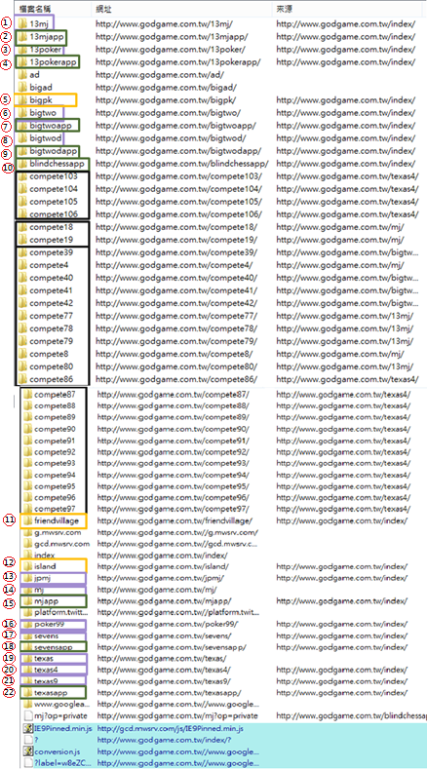
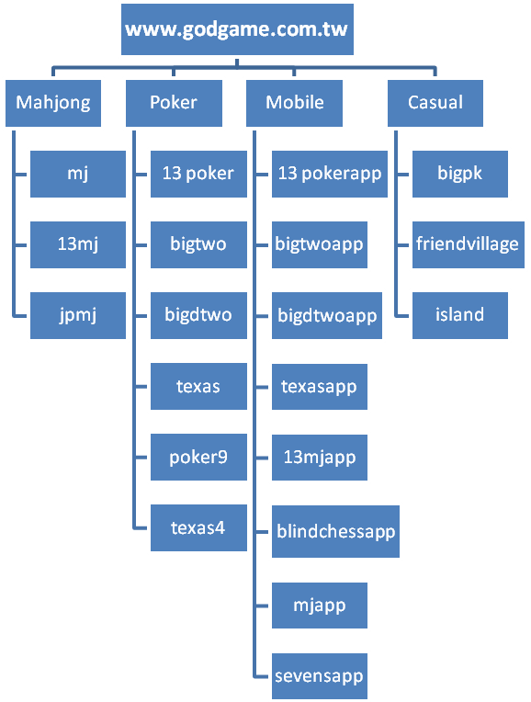
This tree diagramwas generated from the site map.

Technique of connection
In order to know how its’ game work, we use a software(Fiddler) to catch the package that send and receive from God game’s server.
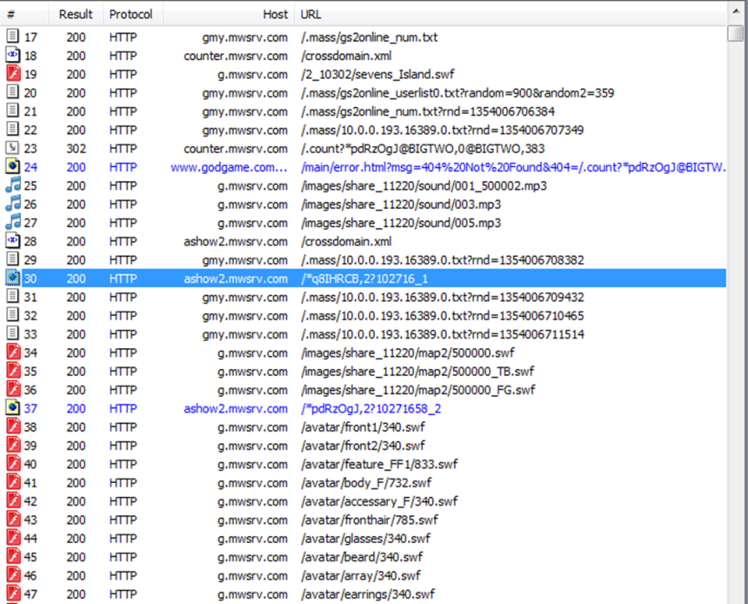
This picture shows that God game has at least 4 servers for website, game server and game data. We alse can sure that game use HTTP protocol to communicate with server.

HTTP Header Analysis
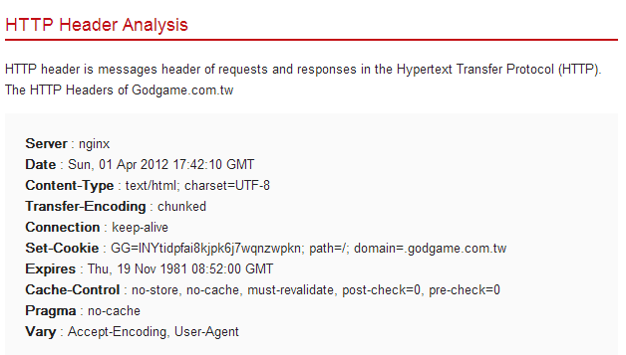
Source: http://www.statmyweb.com/
Due to the advantages, Godgame choose the platform difference with others called Nginx.

Nginx
- Igor Sysoev started development of Nginx in 2002, with the first public release in 2004.
- Nginx (pronounced engine-x) is a free, open-source, high-performance HTTP server and reverse proxy, as well as an IMAP/POP3 proxy server
- Nginx is known for these characteristic
  - high performance
  - stability
  - rich feature set
  - simple configuration
  - low resource consumption

Audience Demographics

Relative to the general internet population how popular is godgame.com.tw with each audience below. This survey provide the information for age, gender, has children or not, education and their browsing location.

Items | Description
Age | - Relative to the general internet population, 18-24 year olds are greatly under-represented at godgame.com.tw.  - Relative to the general internet population, 25-34 year olds are under-represented at godgame.com.tw.  - Relative to the general internet population, 35-64 year olds are over-representedat godgame.com.tw.
Gender | - Relative to the general internet population, Males are under-represented at godgame.com.tw.  - Relative to the general internet population, Females are over-represented at godgame.com.tw.
Has Children | - Relative to the general internet population, people with children are under-represented at godgame.com.tw.  - Relative to the general internet population, people without children are over-represented at godgame.com.tw
Education | - Relative to the general internet population, people who did not go to college are over-represented at godgame.com.tw.  - The audience forgodgame.com.tw among people some college education is similar to the general internet population.  - Relative to the general internet population, people who went to college are over-represented at godgame.com.tw.  - Relative to the general internet population, people who went to graduate school are under-represented at godgame.com.tw.
Browsing Location | - The audience forgodgame.com.tw among people browsing from home is similar to the general internet population.  - Relative to the general internet population, people browsing from school are over-represented atgodgame.com.tw.  - The audience forgodgame.com.tw among people browsing from work is similar to the general internet population.
Source: http://www.alexa.com

