Electronic Commerce Development and Management Final Report

Analysis of Lativ
http://www.lativ.com.tw

Advisor：John Sum
Members：
7100026108 Aaron
7100026114 Ariel
7100026104 Mars
7100026108 Aaron

Outline
1. Introduction of lativ.com.tw 3
2. Marketing Strategy 4
3. Buying Process 4
4. Website Interface 4
5. Business Model 6
6. Target User 7
7. Business Operation 8
7.1 Organization structure 8
7.2 Lativ’s Logistics center 10
7.3 Website infrastructure 11
8. The technologies behind Lativ 12
8.1 Server environment 12
8.2 Programing language 12
8.3 Link analysis 14
8.4 Picture server 16
8.5 Featured functions 17
9. Comments 20

About This Report
This report is a follow-up of the midterm project. Some of the basic information about lativ.com.tw such as its history, services, revenue and marketing strategy would be mentioned in this report. The further study of lativ.com.tw would also be covered in this report. For instance, it’s Business Model, website’s architecture and underlying technologies.

Introduction of lativ.com.tw
“lativ” was found in 2007, the CEO 張偉強 brought their simple designed clothes to the market. The well-known product is the one hundred and sixty eight NT dollar polo shirt with thirty-eight colors. All of their products are made in Taiwan. This character makes customers feel reliable about the quality. The other key successful factor is their logistics system that would be discussed later. Another KSF is the marketing strategies. The CEO learned a lot from their main competitor- Uniqlo. He insists that lativ’s quality is good as Uniqlo but the price is only a half.
According to an article in Business Weekly, Lativ’s revenue reaches 1.5 billion NT dollars in three years that grows one hundred and fifty times (see table 1.1). In this report, we are going to discuss the key factors contribute the success of lativ.

Year | Revenue (billion)
2007 | 0.01
2008 | 0.1
2009 | 0.37
2010 | 1.5
Table 1.1 Lativ’s Revenue

Marketing Strategy
There are three points in marketing strategy are presented as follow. First, lativ provides the information to customers that compare to Uniqlo, they have the same quality but the half price. This is the key point they want to tell customers in their advertisement. Second, they are trying to find depth and extent of customer’s need by collecting feedback and display it on website and observe “User Access log” of the website. Customers can leave messages on the guest board by using their e-mail account. By observing customers’ access log, they can base on the information to analyze their activities in order to find customers’ need. Third, their high frequency of advertisements on YAHOO!, Youtube and other popular websites.

Buying Process
By researching the customers buying behaviors on lativ, this study concludes the buying process to three procedures. First, customers search products by browsing the website. The second step is to put their orders into shopping cart. The last step is to pay the bill by credit card or lativ provides the service that customers can take their goods and pay the cash at 7-11. Through the purchase process, customer can complete the shopping on lativ.

Website Interface
In the section, this study would introduce the website functions of lativ. From figure 3.1, we can see the similarity design between lativ and Uniqlo. On the homepage, customers can type the product number or name to search product. On the top of page, there is the category bar contain women, men, kids and new style. After linking one of the category, others categories show on the left side such as newest product and bargains. Also, some basic classification like clothes, jackets, pants and accessories are show on the page. Customers can base on the fitting report or size chart (Figure 4.2) to pick up their size. After chosen product, customers need to fill out the payment form about their information. Finally, customers decide to pay by credit cards or cash on delivery at 7-11.

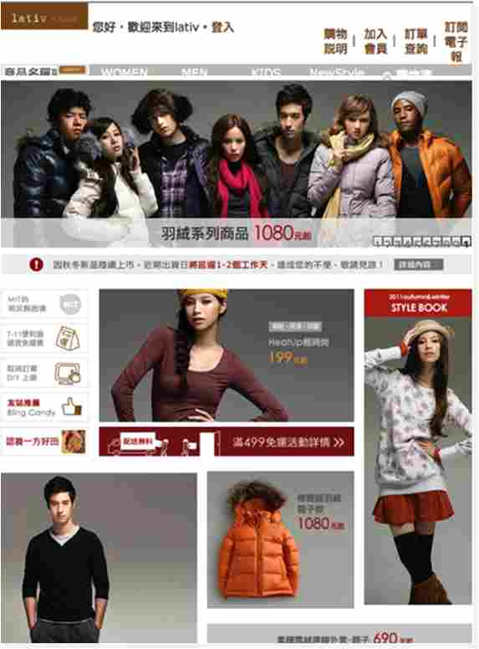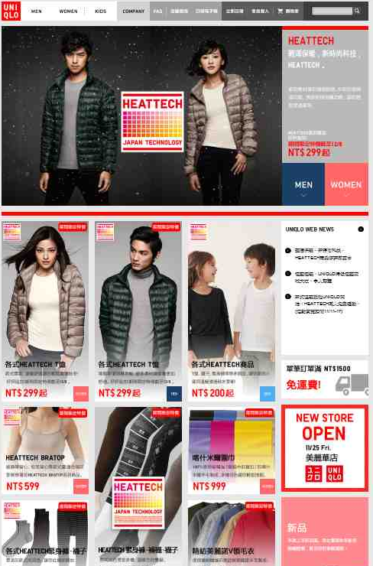
Figure 4.1 Website interfaces of lativ and Uniqlo
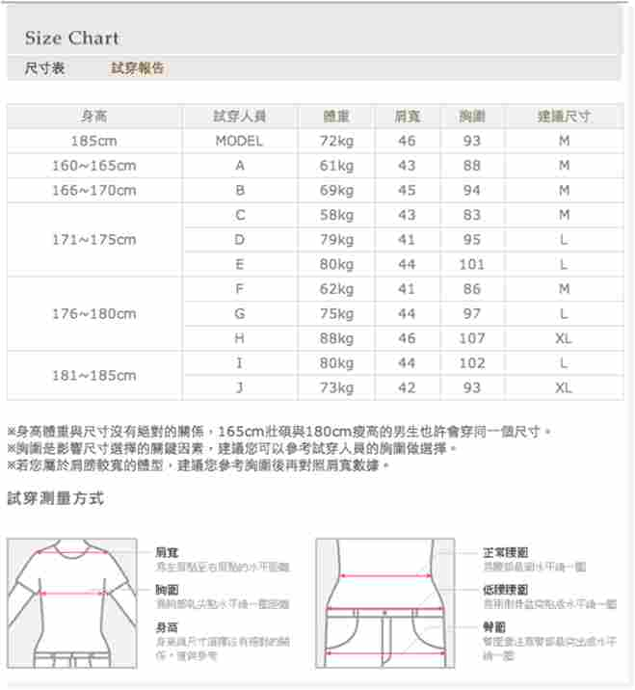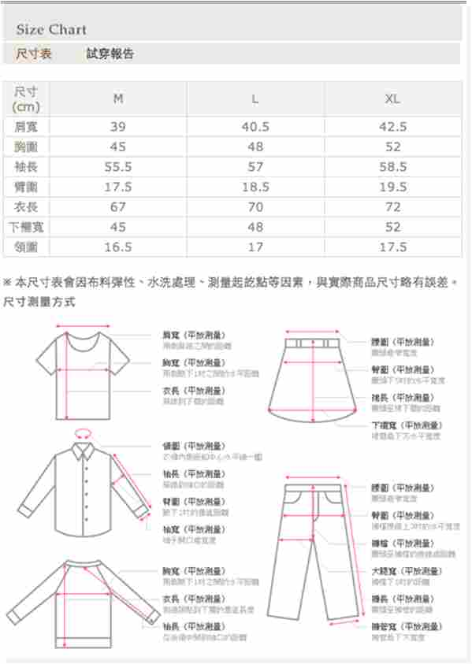
Figure 4.2 Fitting report and size chart

Business Model
“lativ” has two main suppliers that produce the clothes for them. One is called MAKALOT and another one is called ECLAT. Both of them are the top textile companies in Taiwan. Also, lativ need to pay to their suppliers so the cash flows are shown as figure5.1. By ordering goods from Internet, customers can receive their commodities through two ways. One is lativ’s logistic system directly delivery to customers. Another one is customers take their goods and pay at 7-11. This kind of payment is called “cash by delivery”. Of course, lativ should pay the commission to 7-11 by providing this service. From figure 5.1, it shows where the cash flow and product flow go.
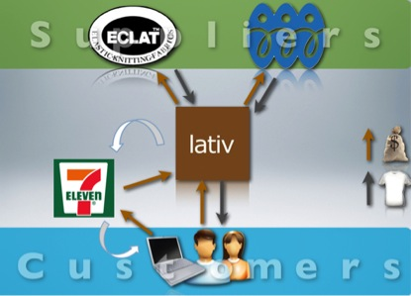
Figure 5.1 lativ business model

In this report, we are going to compare their old model and the new model of delivering goods. Before lativ build the logistic center, they rely on the third party logistic company to do the delivery. (Figure 5.2) After the logistic center was built, they have the ability to send the product to the customer or to 7-11. (Figure 5.3) This change makes lativ cost down and easy to control the time of delivery.
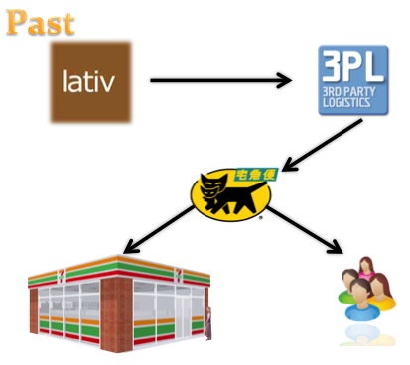
Figure 5.2 The old delivery model
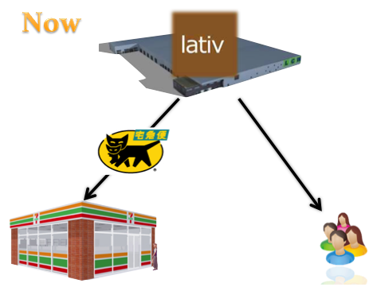
Figure 5.2 The old delivery model

Target User
From their marketing strategy, we find out that their target users are the young parents with kids. The categories on the top of the websites are men, women and kids. They also put the image that parents with kids wear lativ clothes on the website. From this information, we can know lativ not only focus on the young people but also the young families.
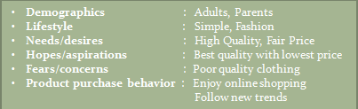
Figure 6.1 Target User

7. Business Operation

7.1 Organization structure
The organization structure of Lativ is an interesting issue to discuss since Lativ has been growing so fast in a couple years. However, the organization structure seems to be a secret for Lativ. After contacting to the Lativ customer service, they refuse to answer any question about their organization structure as well as their business operation. Therefore, we tried to draw the Lative’s organization chart by integrating all the cues we found on internet. Following are the process that we came out this chart. As shown in Figure 7.1
Firstly, we searched on 104 job bank and found that Lativ is recently recruiting about 150 employees for 5 job titles, including quality manager, accountants, procurement, customer service, and human resource. Therefore, we are able to speculate that Lativ has financial department, human resource department, and customer service department. Secondly, since we know Lativ already built it’s own logistic center in 2010, we speculate that Lativ has a logistic department in charge of warehouse & logistic planning. Thirdly, since we know Lativ has built it’s own IT infrastructure; we believe Lativ has an IT Department taking care of those servers.
Lastly, we believe there should be a R&D department in charge of the design of various products produced by Lativ, and a marketing department in charge of each kind of sales promotions on the website.
Figure 7.1 Organization chart of Lativ

We believe the reason that Lativ opened so many jobs is because it is growing so fast in this year, 2011. According to the analysis service provided by Google trends, it shows that the daily unique visitors of lativ.com.tw is growing with a tremendous speed, especially in last three months. As shown in Figure 7.2

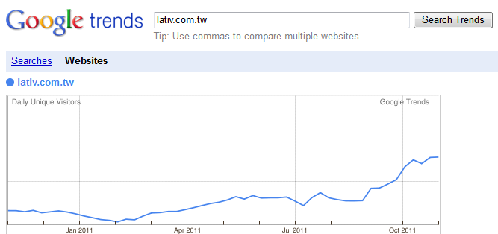

Figure 7.2 Daily unique visitors of lativ.com.tw

7.2 Lativ’s Logistics center
According to an article of CommonWealth(天下雜誌) in June, 2011, Lativ has built it’s own logistics center in Bade City,Taoyuan in July,2011. Lativ spent about 300 million on building this huge logistics center, which can help Lativ save a lot of money on logistic fee. On the other hand, this logistic center also serves as an office building and warehouse, which can help Lativ save the money for renting office and warehouse. Figure 7.3 shows the appearance of Logistics center.
Operation cost goes down in:
  - Logistics fee for 3rd party logistic company
  - Office rental fee
  - Warehouse rental fee

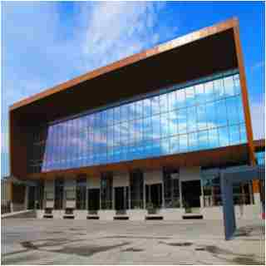

Figure 7.3 Lativ’s logistics center

7.3 Website infrastructure
The DNS of Lativ is “ns1.miniasp.com”, the DNS service is provided by Doggy Digtal. Lativ registers the DNS name from seednet, this service cost Lativ NT$800 a year.
The website of Lativ is also designed by Doggy Digtal.
The server of Lativ is Hermes M250 which is produced by JCNet. But we can not find the price of this kind of server when Lativ bought these servers, so we search this kind of server’s price through the Internet directly, and we find the price in a bank’s procurement list on the Internet finally, these servers’ price is NT$118,923, maybe Lativ is not buy these servers under this price, but we believe that there is no big difference between two organizations when buying these kind of servers.

8. The technologies behind Lativ

8.1 Server environment
Before we start to analyze the technologies used in lative.com.tw, we have to find out the server environment installed in Lativ’s server. The two most commonly used servers are Microsoft IIS server and Apache server. According to the website analysis service provided by http://url-info.appspot.com/, we found that Lativ install the Microsoft IIS 7.5 server environment. Figure 8.1 shows the analysis report.

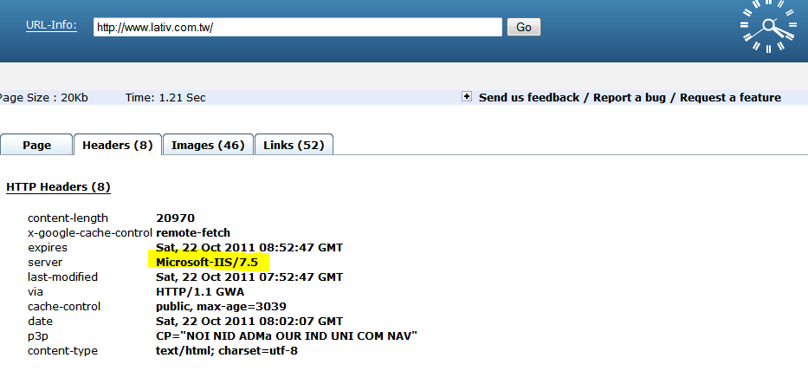
Figure 8.1 Url-info analysis report

8.2 Programing language
The two most widely used dynamic languages are PHP and ASP.Net, the main difference between them is that PHP is an open source software, while ASP.Net belongs to Microsoft product. When we look into other online clothing websites, we can easily find out the dynamic language used in their website by looking to the URL (.php or .asp)
However, when we looked into Lativ’s website, seems that the URL has been re-written or hidden. Therefore, we had to try other ways.
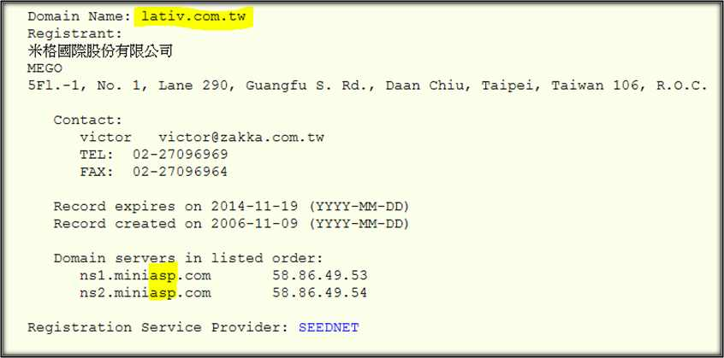
First, since we already knew that Lativ installed the Microsoft IIS environment, at this point we are able speculate that Lativ might use ASP.Net, which is also the product from Microsoft. Secondly, after checking the domain registration information from TWNIC (Taiwan Network Information Center), we found that the domain servers of lativ.com.tw are called ns1.miniasp.com and ns2.miniasp.com. Both of two server names contain “.asp”. Figure 8.3 shows the domain registration information

Figure 8.3 Domain registration information from TWNIC

At last, we went to 104 job bank and checked for the recruitment information posted by Lativ, we found that Lativ are recruiting engineers who are good at ASP.net instead of PHP. Finally, we can almost confirm that the dynamic language used in lativ.com.tw is ASP.Net. Figure 8.4 shows the job requirements posted by Lativ.

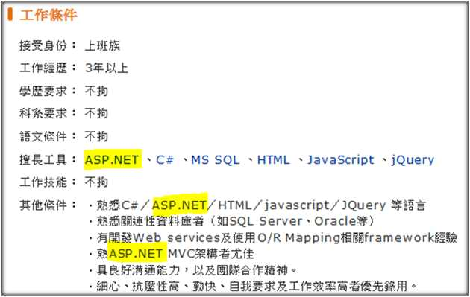
Figure 8.4 Job requirements posted by Lativ

8.3 Link analysis
https://www.lativ.com.tw/Home/Login---Login https://www.lativ.com.tw/Home/Logout---Logout
https://www.lativ.com.tw/Home/Join---Join the member https://www.lativ.com.tw/Home/Login?ReturnUrl=%2fMember---Check order
https://www.lativ.com.tw/Home/EPaper---Subscribe the e-paper
http://www.lativ.com.tw/Home/NewStyle---The newest style
http://www.lativ.com.tw/WOMEN--Women Category
http://www.lativ.com.tw/MEN--Men Category
http://www.lativ.com.tw/KIDS--Kids Category
http://www.lativ.com.tw/OnSale--Promotion Products
http://www.lativ.com.tw/Detail--Normal Products Page
http://www.lativ.com.tw/shopping/index--Shopping cart
http://www.lativ.com.tw/Page/member_frequently_asked_questions--F&Q
http://www.lativ.com.tw/Page/About--About Lativ
http://www.104.com.tw/jobbank/custjob/index.php?r=cust&j=5e4a4425346c3e6948423a1d1d1d1d5f2443a363189j01&jobsource=checkcpage%3D1#02--Job information
http://www.lativ.com.tw/Page/news#20120102-- News
http://www.lativ.com.tw/Page/711new_return--Return policy
http://www.lativ.com.tw/Page/cancel_order--Cancel order
http://www.lativ.com.tw/BrandBlog/20111227--Brand Blog
http://www.lativ.com.tw/Page/distribution_pickup_questions--
Distribution Q&A
http://www.lativ.com.tw/Page/return_product_and_withdraw_questions--
ReturnQ&A
http://www.lativ.com.tw/Page/invoice_questions--Invoice Q&A

Above all, the most frequently used function in the website is Detail.asp, which is used to show the product page for all the products. Following the Detail.asp is a unique string for each product. Looking into the strings representing different kind of products, we found that each string contains 3 messages, including the product number, color, and the size of a product. The first 5 digits represent the product number, the sixth and seventh digit represents the color, and the last digit represents the size. For example, if there are 9 different colors and 4 different sizes that consumer can choose on a single product, the sixth and seventh digit will range from 01 to 09 and the last digit will range from 1 to 4 depends on the consumer’s choice. Figure 8.5 shows the product page.

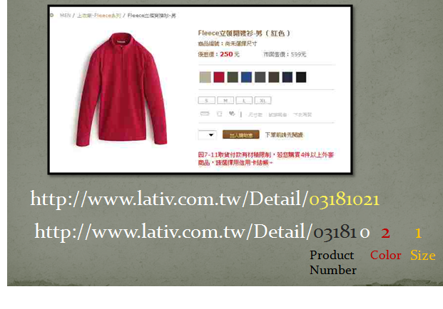
Figure 8.5 Product page

8.4 Picture server
The reason we look into the picture server is that Lativ need to place many pictures on each product page. Averagely, every product needs 15 pictures, which means Lativ needs to store 45,000 pictures on the server if there are 3,000 products on the website. To find out all the picture servers, we record all pictures’ URLs of a single product. Finally, we found that Lativ stores pictures on four servers, as show in Figure 8.6, there are i1, i2, i3, and i4.
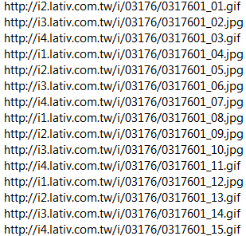
Figure 8.6 Picture servers
We believe the reason Lativ stores pictures on four different servers is that it prevents one of the servers suddenly goes down. If it happened that one of the servers goes down, the rest of the servers still can server three-fourth of the 15 pictures so that customers won’t be interrupted in the process of shopping.

8.5 Featured functions
In this report, we looked into two featured functions, the dynamic shopping cart (see Figure 9) in Onsale.asp and the dynamic mini shopping cart (see Figure 10) in Detail.asp. We checked the programing code of these two functions and found that both of them are written with Ajax. With Ajax, web applications can send data to, and retrieve data from, a server asynchronously (in the background) without interfering with the display and behavior of the existing page. Figure 8.9and 8.10 shows the programing code of these two functions.
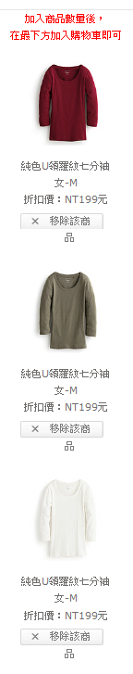

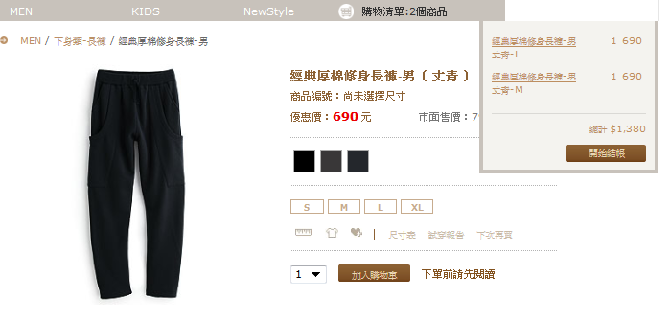
Figure 8.8 Dynamic mini shopping cart

Figure 8.7
Dynamic shopping car

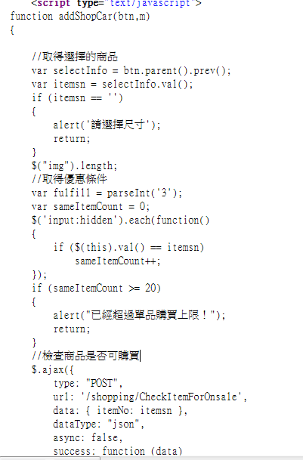

Figure 11

Figure 8.9 dynamic shopping cart
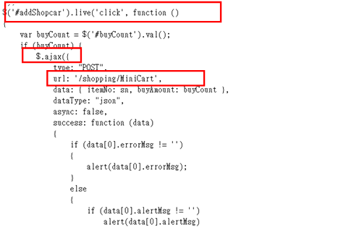

Figure 8.10 dynamic mini shopping cart

9. Comments
After analyzing lativ.com.tw, as a conclusion, we have some comments for Lativ. First, we found that the guest board of Lativ receive comments only from E-mail, which means consumer couldn’t leave comments directly on the guest board. Some people might argue that the messages shown on the guest board are not truly from consumers or those messages have been edited before posting on the guest board. Second, after subscribing to the Lativ newsletter, we found that the newsletter from Lativ is always blogged by Hotmail. Consumers who use Hotmail may encounter the same problem. At last, we found that it is difficult to call the consumer service center. We believe this problem is result from the sharp increase of consumers, and we believe it is also the reason that Lativ is recruiting so many employees for consumer service recently.

