- History
YouTube Milestones
Founded in February 2005
- First video uploaded to the site (April 2005)
- Google acquires YouTube (October 2006)
- YouTube mobile site launched (June 2007)
- YouTube Partner Program launched (December2007)
- Live-stream of U2 concert (October 2009)
- YouTube exceeds 2 billion views a day(May 2010)
YouTube websites was found in 2005 .In the next year, Google acquires YouTube that they share the resource in the organization .In 2007, YouTube mobile site launched that could help someone who had a smart phone connect the YouTube website directionally. In the same year, YouTube Partner Program launched which means the one who upload their film to the websites could have the chance to cooperate with YouTube .If the film was really popular, the partner could get bonus from YouTube. In 2009, YouTube upload Live-stream of U2 concert. YouTube has the technology to provide a live show. Now, YouTube exceeds 2 billion views a day that the main reason why so many advertisement put their advertisement on the YouTube websites.
2. YouTube Potential customers
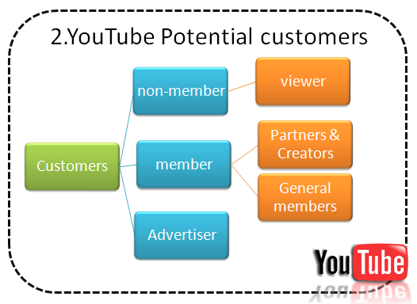
Fig. 1: YouTube potential customers
The potential customers of YouTube website could be classify into three main part non-member, member, and advertiser:
- Non-member:
Someone could visit the YouTube without login and take a look on the web sites. They could use some playing function on the YouTube and search the film that they really like. We describe it as a viewer.
- Member:
- general member
Someone has to login the YouTube website and could use the function to play the film on the YouTube. The entire member could manage their own account and upload the film to the YouTube website. The member also can collect the film form others.
- The partners and creators
The partner and creators have the same right to management the YouTube account with the general member. The creator is someone who could make a film by their own and upload it to the YouTube website. When the web page that they had upload was really popular . YouTube will cooperate with them and give them some bonus that encourages the creators to create more interesting films. The partners are the one who own the copyright of a song or a film. For example, the Warner has lots of copyright or intellectual property right. If YouTube want to play the film or song own by Warner they have to get the copyright from them.
- Advertiser:
The advertiser has to be Google’s member first. After login the Google account, the advertiser could put the advertiser banner on the place that they want and give Google the pay. Different kinds of banner advertisement place will have different unit fee.
3. YouTube Functions
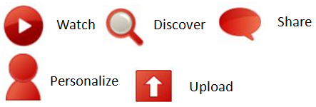
Fig. 2: YouTube functions
These are the main five functions of YouTube websites, watch discover share personalize, upload:

Function | Member  (login) | Non-member  (do not need to login)
Watch | - A member could watch a film without login.  - If a member like the film they can give it a “like “and write down the comment on the web page after login. | - A non-member could watch a film without login
Discover | - A member could do the keyword search and browse without login.  - A member could subscribe and recommend the film they like after login. | - A non-member could do the keyword search and browse without login.
Share | - A member can share and embedded a film to another website. | - A non-member can share and embedded a film to another website.
Personalize | - A member can management their own account:  The style of the playlist, favorite films collect the films that had been played. | - A non-member cannot management their own account.
Upload | - A member can upload the legal film to a websites after login. | - A non-member cannot upload the legal film to a websites.

4. YouTube organization department
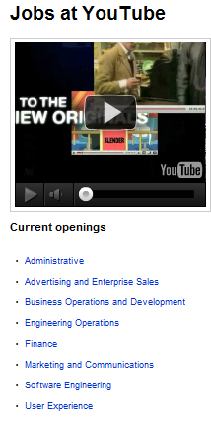
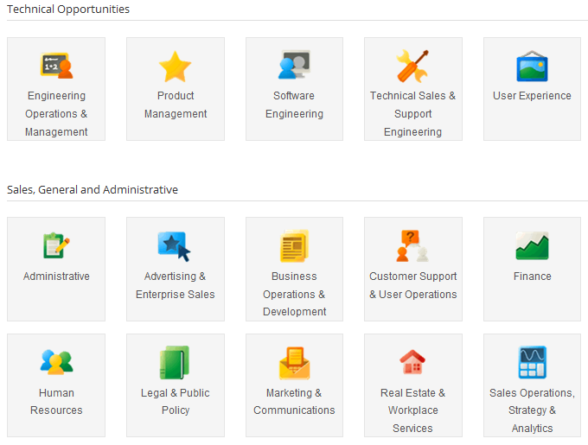
Google‘s organization department
Fig. 3: YouTube department
Google acquires YouTube at 2006.Therefore,it is a hard work to find out the YouTube’s organization department chart. Instead, we found the recruit information from the YouTube’s websites and found some opening jobs. The current openings are administrative, advertising and enterprise sales, business operations and development, finance, marketing and communications, software engineering, user experience. These current openings have the same name with some of the Google’s organization department, so we believe YouTube is part of Google’s organization.
5. YouTube Business model 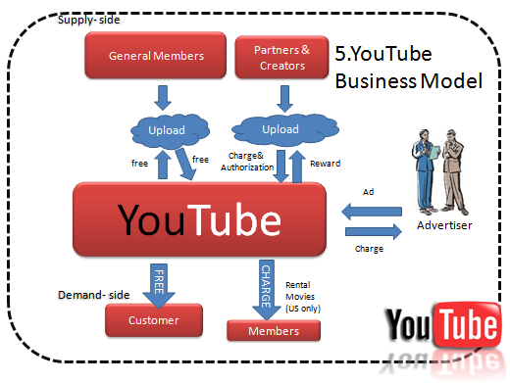
Fig. 4: YouTube Business model
The YouTube get the revenue in different way. The general members upload the film free. Then, YouTube also offer free films for the other general members and members. The partner and creators will charge and give the authorization to YouTube website. YouTube will give them reward to encourage the cooperation. The member who is in the USA has the right to rental some movies. The advertiser will put some banner if the YouTube web page was really popular. YouTube could charge with them and earn the money.
6. Operation Cost
According to Credit Suisse, YouTube’s estimated revenue was 240 million dollars (U.S.) in 2008. But their estimated expenses were 753 million dollars (U.S.) in 2008 which means YouTube still losing money at that time. Most of revenue came from advertisement. And the expenses include bandwidth, content acquisition, partner revenue share, site overhead and storage. The main costs are bandwidth and content acquisition. Although estimating that YouTube pays about half the lowest market rate for bandwidth, the cost still very expensive because of the incredible amount of bandwidth usage.
7. Revenue sources of YouTube
Fig1
Fig. 5: Revenue sources model of YouTube
7.1 How does YouTube make money?
Since YouTube was acquired by Google, and Google didn’t release any financial statement on the internet, how could people judge weather YouTube is making money or not? What are the revenue sources of YouTube? We could only make our own predict after researching variety information.
First, we have to make sure what the revenue sources of YouTube are? According to the survey of eBizMBA Rank*, YouTube takes the first place of Most Popular Video Websites in December 2011, and there are over 3 billion videos views per day. From the data above, we could speculate that YouTube is a big market for advertisers to do company/ product promotion on it. By placing the ads, advertisement could not only increase company/product exposure but also increase customer purchase intention.
Second, according to the “Frequently asked questions “of YouTube, there is a question called “How does YouTube make money”, and the answer from official website is “As the world's largest online video site, many advertisers are interested in running campaigns that reach our audience. Advertisers can buy ads on the YouTube homepage, search results pages, and even within the videos themselves. They also run contests and sponsor events such as live concerts and holiday promotions. Consequently, we believe that advertisements are the main revenue sources of YouTube.
7.2 The advertisements form of YouTube
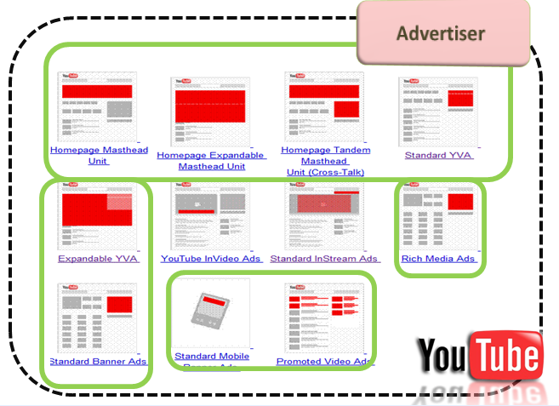
Fig. 6: the advertisement form of YouTube
Fig. 6 shows the 11 different advertisements placement. There are nine different displacements which are provided to advertisers setting their advertisements. There are 1.homepage masthead. 2. Homepage expandable masthead unit. 3. Homepage tandem masthead. 4. Standard YVA. 5. Expandable YVA. 6. Rich media ads. 7. Standard banner ads. 8. Standard mobile banner ads. 9. Promoted video ads.

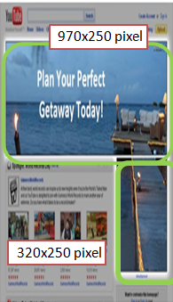
The following will list 5 different ads placements.
First: Homepage masthead
•The homepage masthead is a unit running the full width of the YouTube homepage below the navigation bar.
• A complementary below the masthead on the right and works in tandem with it.

Fig. 7 Homepage masthead

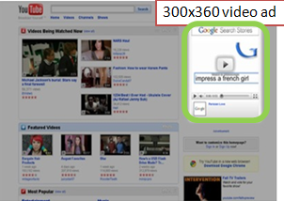
Second: Standard YVA
The Standard YouTube Video Ad (YVA) can function either two ways:
Auto play -
Can only run on YouTube homepage and search pages Click-to-play -
Can run on homepage, search, or browse pages

Fig. 8 Standard YVA
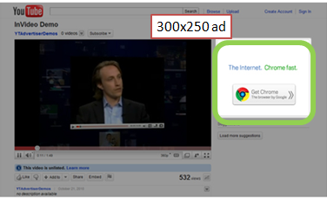
Third : Standard Banner ads
YouTube standard banner ads can run across all areas of the site except the Homepage.

Fig. 9: Standard Banner ads

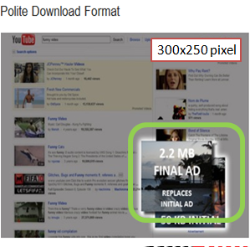
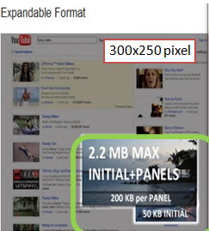
Forth : Rich media’s ad
Rich Media ads must be third-party served and can be in two formats:
Polite download, which run across all 300x250 placements (Search and Watch) or Expandable, which run across all 300x250 placements except on Watch, Premium Watch, or Partner Fig. 10: Rich media’s ad Pages ( US only now)

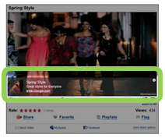
Fifth: Promoted videos
It incorporates a video overlay on top of the video for your Promoted Video to link externally to a website of the owner's choosing. YouTube Promoted Video ads can show on search, browse, watch, or homepages

Fig. 11 Promoted videos
7.3 How does YouTube Charge on Advertisers?
There are CPC (cost per click) & CPM two ways to charge their advertisers.
- CPC: the definition of CPC is that the cost or cost-equivalent paid per click-through.
The terms cost-per-click (CPC) is sometimes used interchangeably, sometimes as distinct terms. When used as distinct terms, CPC indicates measurement of cost on a per-click basis for contracts not based on click-through. For example, consider a campaign where payment is based on impressions, not clicks. Impressions are sold for $10 CPM with a click-through rate (CTR) of 2%.
1000 impressions x 2% CTR = 20 click-through
$10 CPM / 20 click-through = $.50 per click
- CPM: CPM or cost per thousand impressions is an AdSense pricing scheme where webmasters are paid for every thousand times an ad is displayed on a page.
7.4 Estimated Profit of YouTube
Cue1:
Due to YouTube was acquired by Google, and Google released no financial statements of YouTube. So we have to make our own investigate on how YouTube’s financial situation is.
According to Mark Mahaney, the Internet Analyst at Citigroup Investment Research predict, he predicted that the estimated YouTube gross revenue will keep increasing from 2010 to 2012.
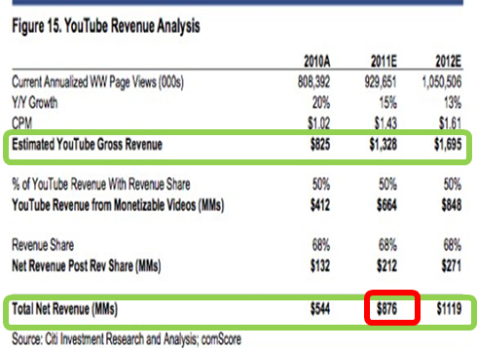
Fig. 12: YouTube revenue analysis by Mark Mahaney (2010)
Cue 2:
According to the official website of YouTube ,it shows that there are more than 1 billion views per day on YouTube in 2009 (see Fig12). Moreover, the amount of views have the extremely increased within 2 years. It had up to 2 billion view per day in 2010. From this report, we speculate that CPC of YouTube ads will also increase in these two years . Consequently, the revenue of YouTube will raise up, too.
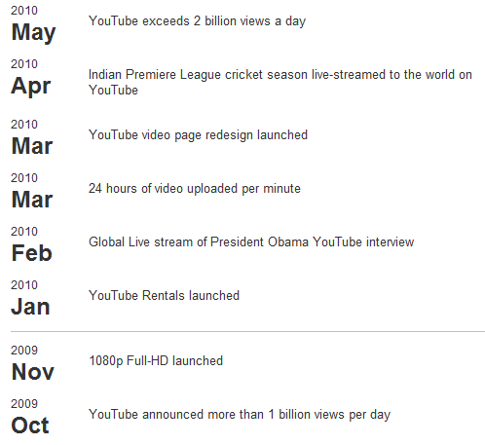
Source: http://www.youtube.com/static?hl=en&template=press_timeline
Fig. 13: YouTube Views per day from 2009-2010
Cue 3:
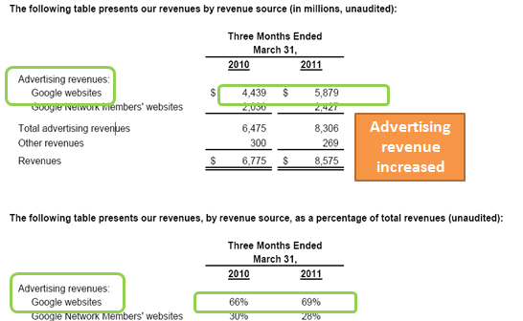
According to the Google's first quarter revenue report in 2011, Google advertising revenue increase 1,440 million from 2010 to 2011, the 3 % increase in total revenue. Since we know that YouTube advertising revenue is also an important source of advertising revenue of Google. We believe YouTube had contribute a part of the 3% increase.
Fig. 14: Google's first quarter revenue report in 2011
Consequently, we conclude that although YouTube's financial status is deficit in 2008, it turns to the positive situation in 2009 due to the huge increase of views (1 billion per day). Furthermore, the cue1, cue2, and cue3 provide evidences that YouTube has turned to profitable situation since 2010.
8. The effect of partnership program
Fig. 15: the effect of partnership program
Partnership program is a kind of revenue sharing model. it provide win-win strategy for both YouTube and users. For viewers who are the partner with YouTube, by participating this program, the videos they provided will be put the ads on them. Once other viewers click the covered advertisements, they could get money from YouTube. For YouTube, once their partners create more popular videos, it will attract more advertisers to cooperate with them. Consequently, they will receive more money from advertisers.
8.1 What is YouTube Partnership?
YouTube partnership is a program that lets you share the revenue generated through videos that you create, upload and share on YouTube. Partners can upload videos without any length or size limit, and can offer their videos for rent which are streamed only after the payment is secured. In addition, protects your copyrights through their Content ID system. YouTube has derived two kinds of partnership programs, which are Individual Video Partnership program (IVP) and YouTube partnership program (YPP). Both of them are invite-only program for individual account.
IVP: In an in account, only specific video can be monetized, as show in Fig 16, only one of the two videos in the same account is monetized.
YPP: While IVP focuses on individual videos, the YPP program encompasses the entire account, which means all videos in an account can be monetized. (see Fig 17)
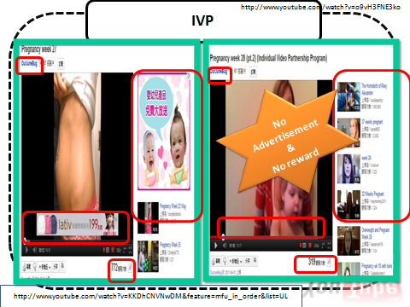

Fig. 16: IVP Partnership

Fig. 17: YPP Partnership
9. Technology
The technologies using by YouTube are Apache, Linux and MySQL. For the web server software, we find some error message indicate that YouTube using Apache. Also we use the service of www.yousiteinfo.com to search YouTube and get some result as Fig. 20. These evidences prove that YouTube is using Apache as web server.
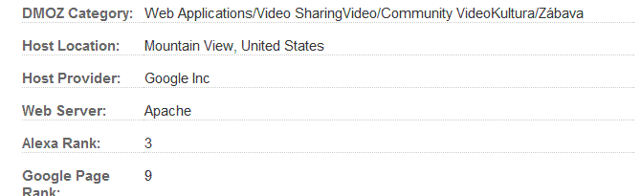
Fig. 20: Web server of YouTube
For the database, there was some recruit information of YouTube on the internet as Fig.21. Because of this information, we can know that YouTube is looking for employees who know about MySQL and we can also know that YouTube is using MySQL as database.
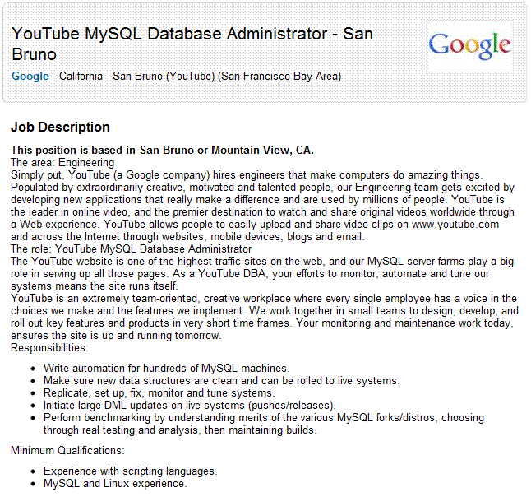
Fig. 21: Database of YouTube
For the same reason, we also find some recruit information of YouTube on the internet which indicates that YouTube is using Linux as operation system as Fig. 22.
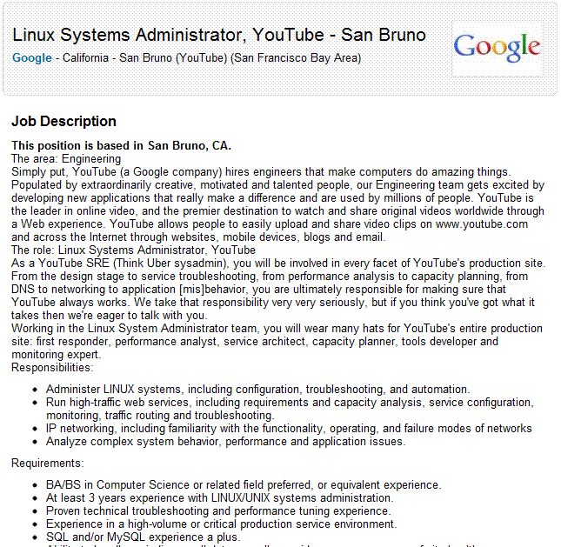
Fig. 22: Operation system of YouTube
In Fig. 23, we use IP tracing software to detect YouTube and the result shows that YouTube is using TCP protocol to transport data.
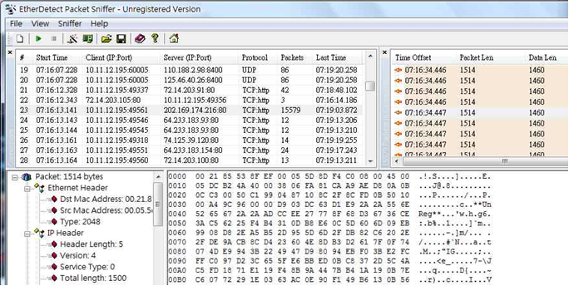
Fig. 23: Transmission protocol of YouTube
We also trying to find out where are the servers of YouTube. And the result shows that there is more than one server of YouTube. And the locations of these servers are in different places (these servers locate in different places). Moreover, we find out that some of the servers of YouTube are sharing with Google.
On the other hand, we find that every video of YouTube has four copies. We revise the video code like “BA7fdSkp8ds” to “BA7fdSkp8dt”, “BA7fdSkp8du” and “BA7fdSkp8dv”. The URLs with these four video code also show the same video. When we revise the video code to “BA7fdSkp8dw”, the YouTube can’t find the video like Fig. 24. Then we try whether the number of backups relation to views or not. We take the other video that only two views to exam, and found that there are no relationship between number of backups and views. All the video has four backups.
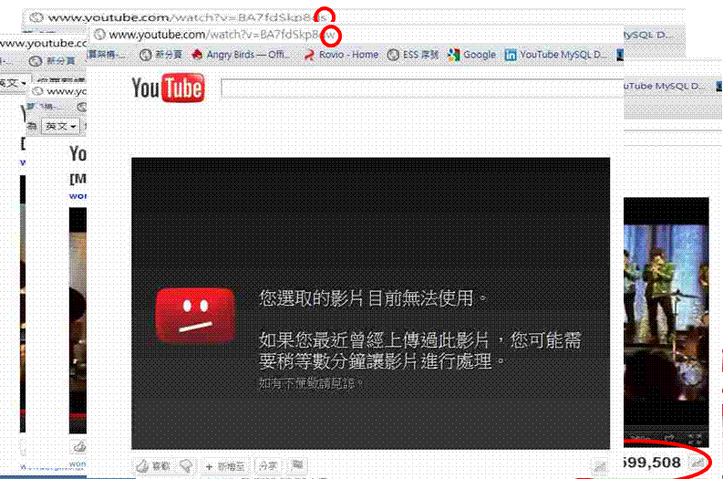
Fig. 24: video backup test of YouTube
10. Video Categories
There are four types of categories of video: “shows”, “music”, “charts” and “movies”.
10.1 shows
There are two directories named “shows” and “show” and a program named “shows” under the Youtube.com.
The program “shows” can generate the dynamic homepage of the shows category. For example:
http://www.youtube.com/shows?hl=en
Under the directory “shows” are at least twenty-two programs, each type of shows has its own program to collect the shows of which type. For examples:
http://www.youtube.com/shows/action-adventure?feature=sh_c&pt=g
http://www.youtube.com/shows/animation-cartoons?feature=sh_c&pt=g
http://www.youtube.com/shows/beauty-fashion?feature=sh_c&pt=g
Under the directory “show”, every show has its own program to generate the introduction page of the show. There are some informations in this page, like episodes, seasons … etc. For example:
http://www.youtube.com/show/theannoyingorange?feature=sh_b_en_2_1
If you want to watch which one episode of this show, click it, then the program “watch” under the Youtube.com will generate the video page and play the video.
10.2 music
There are one program and one directory named “music” under the YouTube.com.
The program “music” can generate the dynamic homepage of the music category. For example:
http://www.youtube.com/music?hl=en
Under the “music” directory are at least twenty-two programs, each type of music has its own program to collect the music of which type. For examples:
http://www.youtube.com/music/latin?feature=mv_c
http://www.youtube.com/music/pop?feature=mv_c
http://www.youtube.com/music/rock?feature=mv_c
After that, choosing one and click it, the program “watch” will generate the video page and play the video.
10.3 charts
There are five types of charts: rank by video views, rank by videos comment count, rank by top rated, rank by high-definition video views and rank by added to favorites. Each type of chart has its own directory and program. For examples:
http://www.youtube.com/charts/videos_comment_count?t=t
http://www.youtube.com/charts/videos_top_rated?t=t
http://www.youtube.com/charts/videos_views_hd?t=t
http://www.youtube.com/charts/videos_views?t=t
http://www.youtube.com/charts/videos_most_added_to_favorites?t=t
The five programs are raking all the type and they can control the period of ranking. For examples:
http://www.youtube.com/charts/videos_views?t=t // rank by day
http://www.youtube.com/charts/videos_views?t=w // rank by week
http://www.youtube.com/charts/videos_views?t=m // rank by month
And we can also choose the categories of videos that we want to ranking. There are at least fifteen programs under the directories. Each category has its own programs to rank. These programs can control the period you want to rank. For examples:
http://www.youtube.com/charts/videos_views/howto?t=m
http://www.youtube.com/charts/videos_views/people?t=t
http://www.youtube.com/charts/videos_views/vehicles?t=w
After setting the rules of ranking and got the result, click the video you want to watch, then the program ”watch” will generate the video page and play the video.
10. 4 movies
There are two directories named “movies” and “movie” and a program named “movies” under the Youtube.com.
The program “movies” can generate the dynamic homepage of the shows category. For example:
http://www.youtube.com/movies?hl=en
Under the directory “movies” are at least fourteen programs, each type of movies has its own program to collect the movies of which type. For examples:
http://www.youtube.com/movies/drama?feature=mv_c
http://www.youtube.com/movies/action-adventure?feature=mv_c
http://www.youtube.com/movies/animation-cartoons?feature=mv_c
Under the directory “movie”, every movie has its own program to generate the introduction page. There are some information in this page, like introduction, running time, …, etc. For example:
http://www.youtube.com/movie/the-young-in-heart?hl=en
Click the button “Watch Now”, then the program “watch” under the Youtube.com will generate the video page and play the video.
11. Other Directories under YouTube.com
11.1 directory “t”
The “t” means “text”. The links under the directory “t” are the documents that describe the rules, guides, introduction of YouTube. For examples:
http://www.youtube.com/t/
http://www.youtube.com/t/about_essentials/
http://www.youtube.com/t/about_getting_started/
http://www.youtube.com/t/about_youtube/
http://www.youtube.com/t/ads_expandable_yva_autoplay/
http://www.youtube.com/t/ads_expandable_yva_clicktoplay/
There are eighty-eight pages under the directory “t”.
11.2 directory “v”
The “v” means “video”. The links under the directory “v” are the video pages that discuss the issues about using YouTube and teach users how to use YouTube and the tools of YouTube. For examples:
http://www.youtube.com/v/6CoTQPK6SEw&amp;fs=1&amp;rel=0&amp;autoplay=0/
http://www.youtube.com/v/8hldfhy63cw&amp;fs=1&amp;rel=0&amp;autoplay=0/
http://www.youtube.com/v/9g2U12SsRns&amp;fs=1&amp;rel=0&amp;autoplay=0/
http://www.youtube.com/v/_6uC1bUzl4E&amp;fs=1&amp;rel=0&amp;autoplay=0/
http://www.youtube.com/v/CHIbhgdHA9E&amp;fs=1&amp;rel=0&amp;autoplay=0/
There are twenty video pages under the directory ”v”.
11.2 directory “user”
Every user can create a channel. Every channel has a program and a directory under the directory “user”. This program generates a dynamic homepage of “my channel”. For example:
http://www.youtube.com/user/ECDMG1?feature=mhee&hl=en
Under the directory are the pages that categorize the videos in the channel, like “All”, “Upload”, “Favorites”. For example:
http://www.youtube.com/user/ECDMG1?feature=mhee#p/a // All
http://www.youtube.com/user/ECDMG1?feature=mhee#p/u // Upload
http://www.youtube.com/user/ECDMG1?feature=mhee#p/f // Favorites

